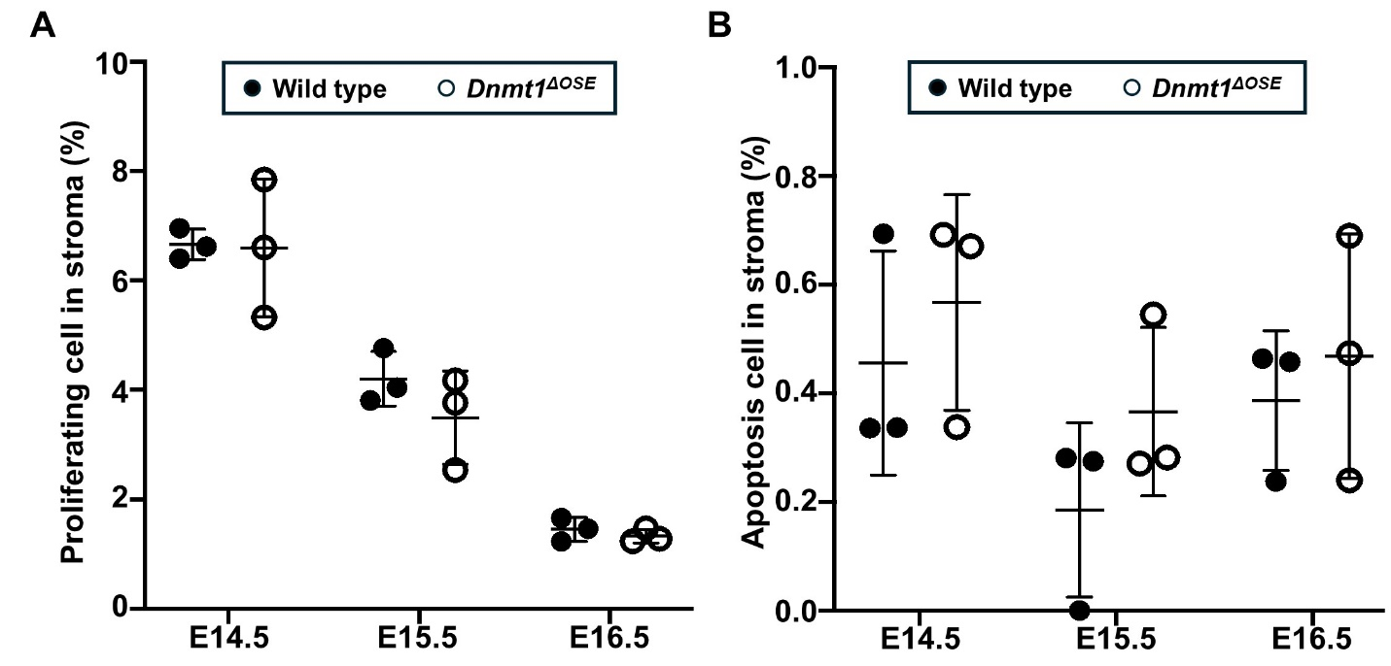
Supplementary Figure 4. Cell proliferation and apoptosis in the corneal stroma. The wild type and Dnmt1^{ΔOSE} embryos at E14.5 - E16.5 were subjected to (A) EdU labeling for cell proliferation and (B) TUNEL assay for apoptosis. The positive cells in the corneal stroma were quantified, and values represent mean ± s.e.m. of 3 embryos/genotype. A two-tailed Student’s t-test was used for the statistical analysis.

