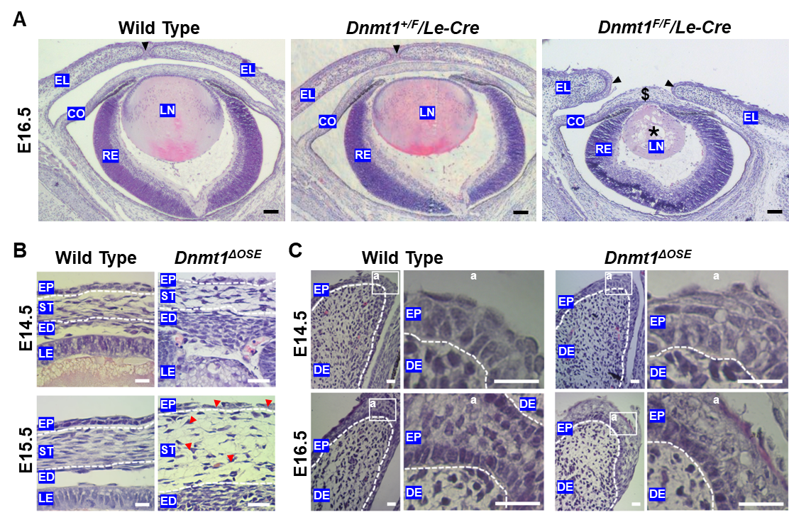

Supplementary Figure 1. Epithelial abnormality in Dnmt1^{ΔOSE} cornea and eyelid. H&E staining of the eyelid tissue sections of E14.5 - E16.5 embryos as indicated. (A) The Arrowheads pointed at the eyelid tip leading edge. The $ labeled corneal edema, the * marked the degenerated lens which only observed in the Dnmt1^{F/F}/Le-Cre (Dnmt1^{ΔOSE}) eyes. (B) The corneas with dashed lines marked the junctions of the corneal stroma; the arrowheads point to the abnormally shaped epithelial cells and keratocytes and basal cell-basement membrane detachment. (C) The eyelids with low magnification (left panels) and high magnification of selected area (a, right panels), and the dashed lines marked epithelial basement membrane. EL, eyelids, CO, cornea, RE, retina, LN, lens, EP, epithelium, ST, stroma, ED, endothelium, LE, lens epithelium, DE, dermis. Images are representative of at least three mice/genotypes. Scale bars: 50 µm for (A), 10 µm for (B) and (C).

