Cell Line Authentication Report for Case Number 21217 – Universite Libre de Bruxelles
Statement
We have now completed DNA analysis of the sample presented for cell line authentication. Analysis has been conducted using the Promega Powerplex 16 HS kit which analyses the differences at 16 distinct hypervariable genetic loci. (Please note that some cell lines may exhibit genetic instability as they proliferate leading to discrepancies within the DNA profiles examined).
Summary
A short tandem repeat (STR) DNA Profile has been generated from the sample provided by Universite Libre de Bruxelles. The sample name is ARPE-19. The profile is shown below together with the profile for cell line arpe-19 from the Cellosaurus website (ref CVCL_0145). The profiles match 100% and were therefore generated from the same source material. Please refer to the detailed results on the second page for further information and interpretation and the notes below on interpreting cell line STR profiles.

Notes on interpretation of cell line STR profiles:
The outcome percentage is calculated using a formula which compares the number of alleles present against the number of alleles shared between the two DNA profiles. The outcome is designated one of the following statements based upon the outcome percentage (more data on the interpretation of cell line STR profiles can be found on the International Cell Line Authentication committee (ICLAC) website using the following link www.iclac.org/resources/match-criteria-worksheet
- For two cell lines with STR profiles matching greater than 80% they are considered to have been generated from the same source.
- For two cell lines with STR profiles matching between 56-79% they are unlikely to have been generated from the same source but further investigation should be carried out.
- For two cell lines with STR profiles matching less than 56% are considered to be unrelated, that is, to have been generated from independent sources.
- On occasion, the cell line STR profile may match one of the cell lines on the international list of misidentified cell lines curated by ICLAC. If this is the case this will be indicated in the summary statement. This list can be found at www.iclac.org/wp-content/uploads/Cross-Contaminations-v8_0.pdf

Summary statement prepared by:  Edward Burnett  Culture Collections  Scientific Development Group Project Manager  Date: 16th February 2021 | 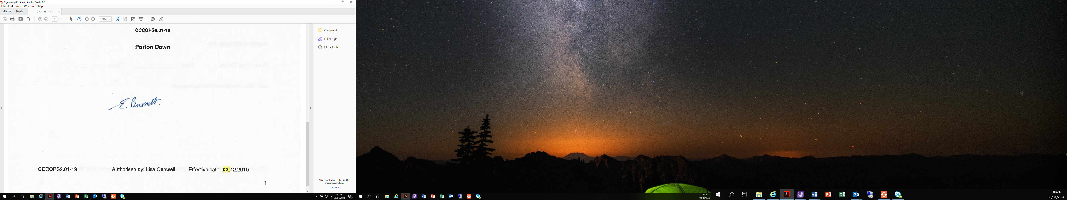
Laboratory Report
Test Requested | Cell Line Authentication
Case Number | 21217
Date Sample Tested | 3/2/2021
Date Sample Reported | 7/1/2021

Sample Name | Sample/Comparison Profile Source | Sample Reference
ARPE-19 | Cellosaurus ARPE-19 CVCL_0145 | S-1047417

Table of Allelic Data |  | Genotypes
STR Locus |  | Test Sample – ARPE-19 – Universite Libre de Bruxelles | Database Sample – Cellosaurus ARPE-19 CVCL_0145
AMEL |  | X,Y | X,Y
CSF1PO |  | 11 | 11
D13S317 |  | 11,12 | 11,12
D16S539 |  | 9,11 | 9,11
D18S51 |  | 12,16 | 12,16
D21S11 |  | 28,29 | 28,29
D3S1358 |  | 14,15 | 14,15
D5S818 |  | 13 | 13
D7S820 |  | 9,11 | 9,11
D8S1179 |  | 13 | 13
FGA |  | 23 | 23
PENTA D |  | 11,13 | 11,13
PENTA E |  | 7,11 | 7,11
THO1 |  | 6,9.3 | 6,9.3
TPOX |  | 9,11 | 9,11
vWA |  | 16,19 | 16,19

