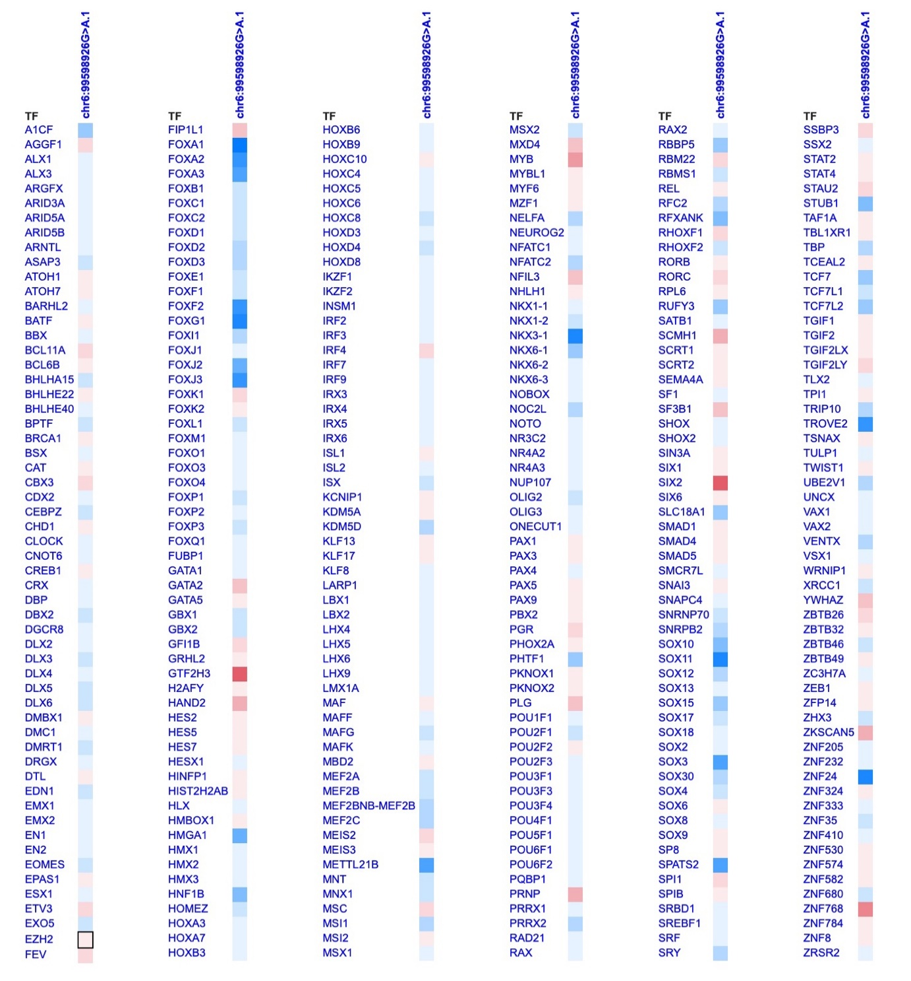
Appendix 8. Transcription factor binding site (TFBS) gain and loss due the variant V18 (chr6:g.99,598,926G>A). The variant V18 might disrupt the binding of SIX2. Blue indicates gain of TFBS and red indicates loss of TFBS (https://www.genecascade.org/fabian/). Deeper shades of color revealed a greater loss or gain. [17]

