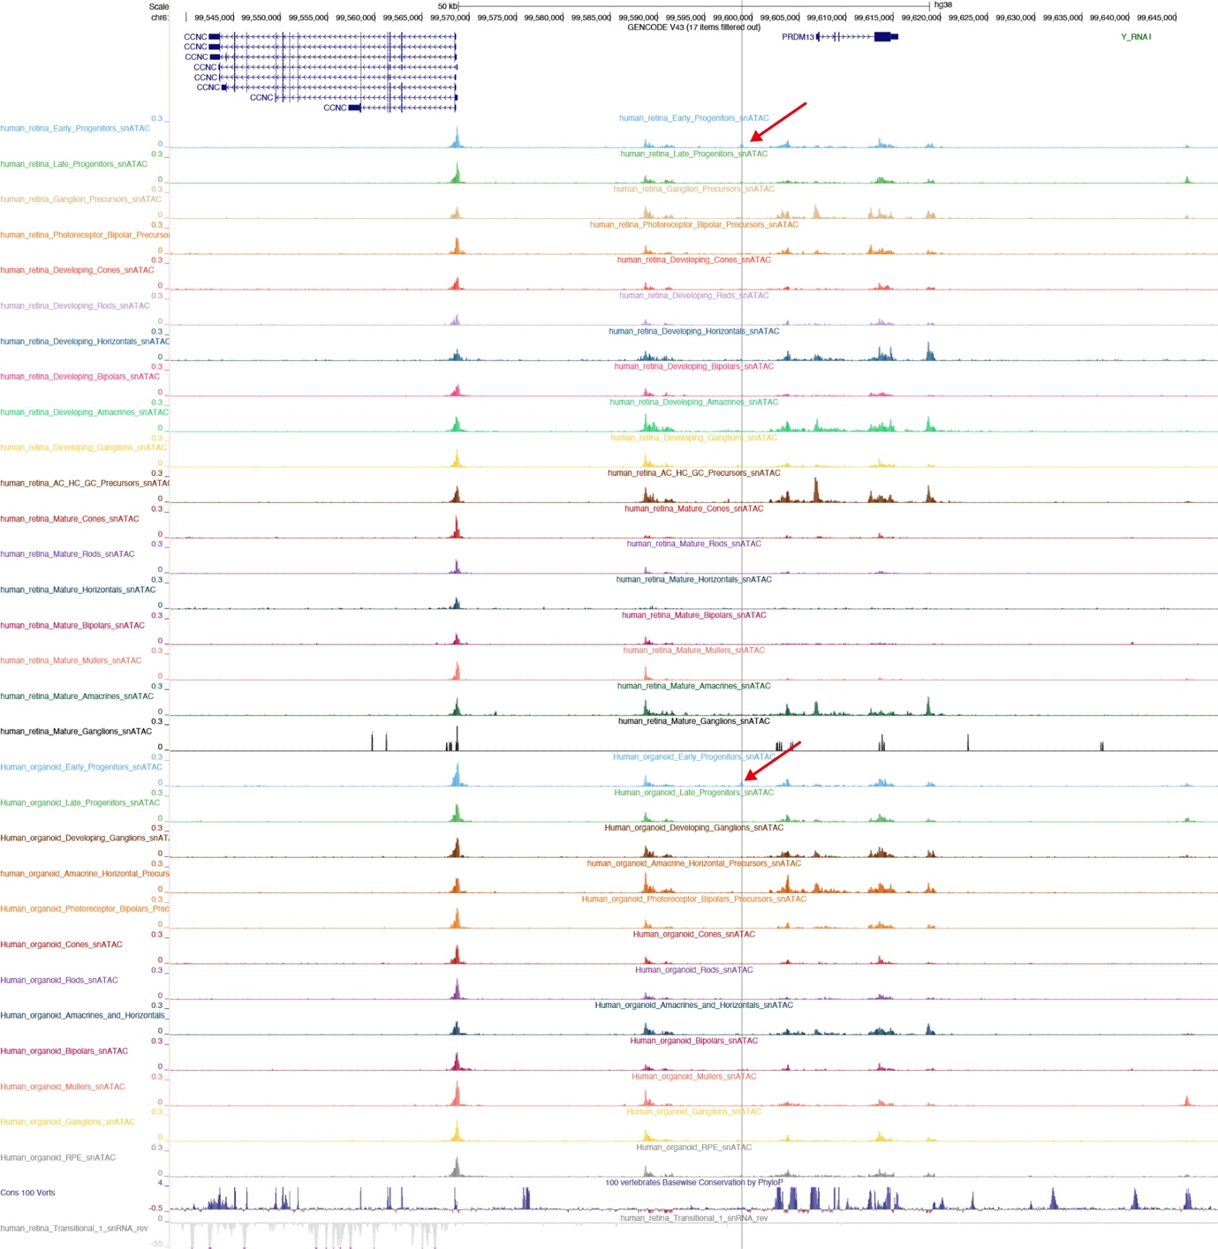
Appendix 6. Single nucleus characterization of chromatin accessibility in developing and adult retina and human retinal organoids (http://genome.ucsc.edu/s/CherryLab/Nuclear_EyeBrowser_TrackHub). [16] The single nucleus assay for transposase-accessible chromatin sequencing revealed that the chromatin structures are open in early retinal progenitor cells only (red arrow) in the PRDM13_cCRE5 regions, which is mutational hotspot-2 (vertical grey line).

