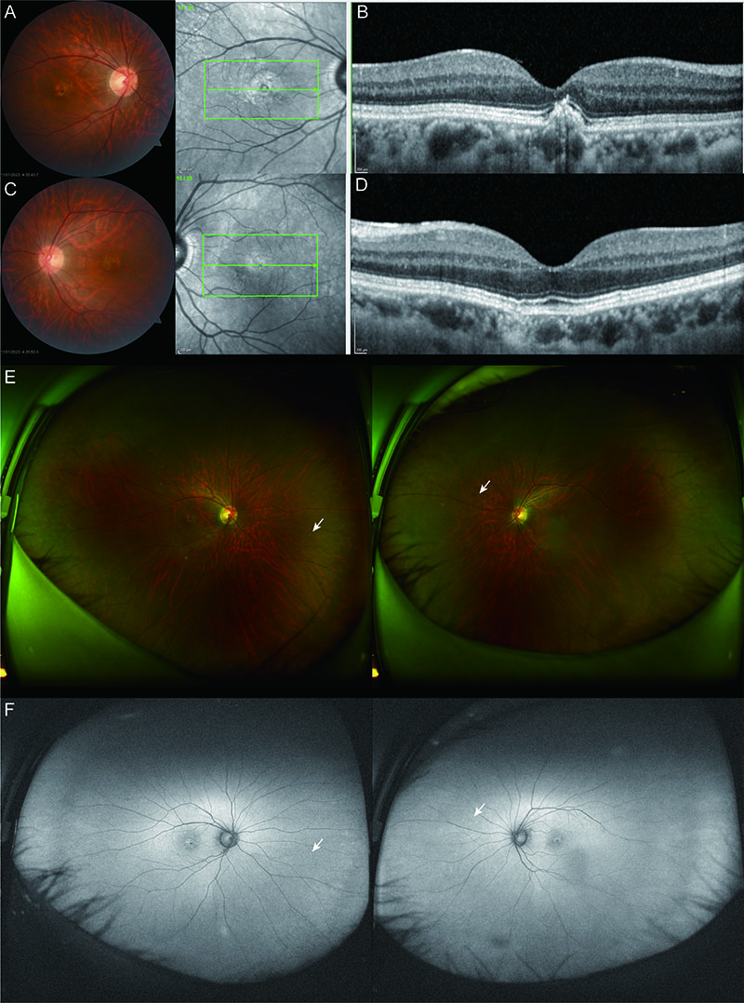
Appendix 5. Clinical findings of subject 1-4 (Family B) (A ,B, C, D). Fundus photographs and OCT on both eyes. (E) Wide-field retinal images of both eyes. (F) Wide-field autofluorescence images of both eyes. White arrow indicates peripheral small drusens.

