Supplementary Figure 2. Slit lamp images of patients harboring different CHST6 mutations. Slit lamp photograph of all MCD patients showing irregular hazy, grey-white opacities (yellow arrows). On the top of the image (white numbers) first number represents MCD patient ID followed by age and sex. A- Different missense mutations, B- Different deletion mutation, C- Deletion insertion mutation, D- ORF deletion mutation, E- Negative mutation.
Supplementary Figure 2.
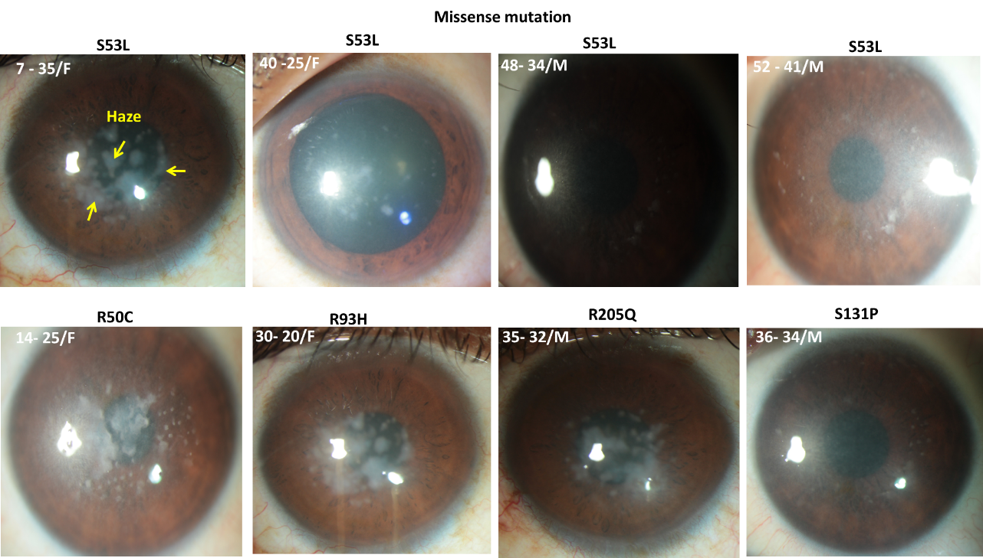
A

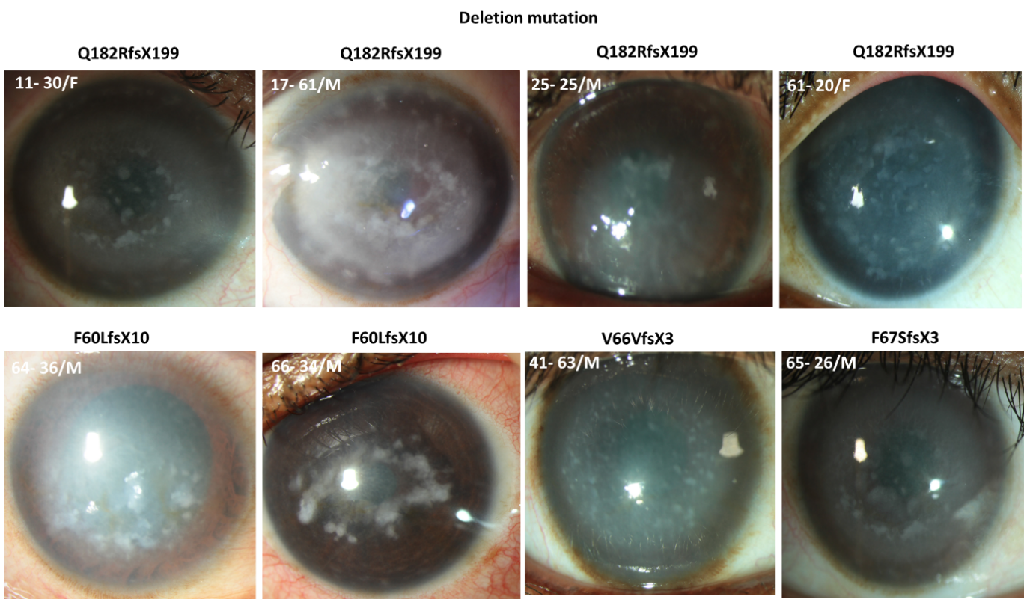
B

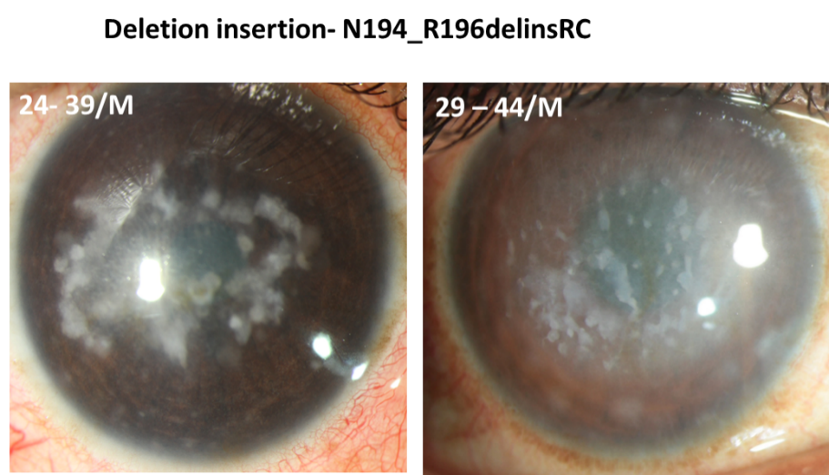
C

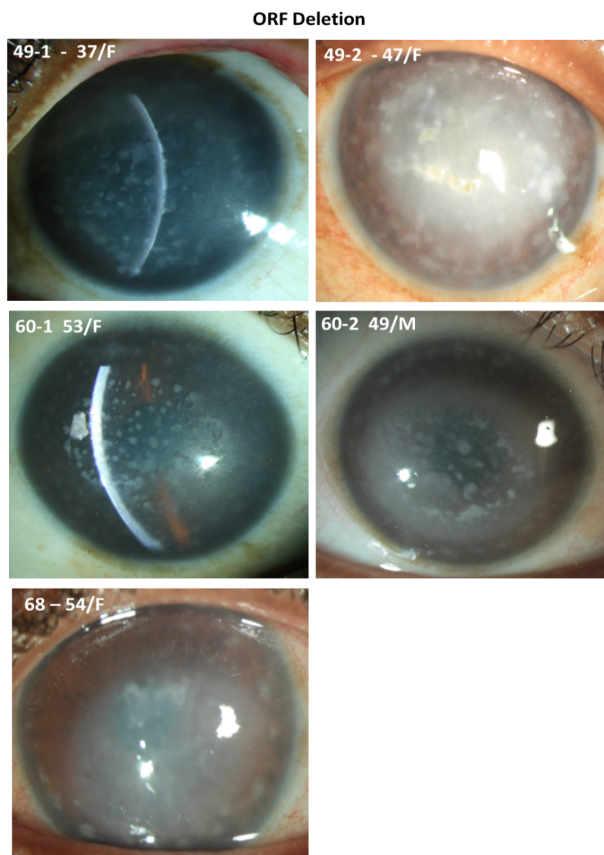
D

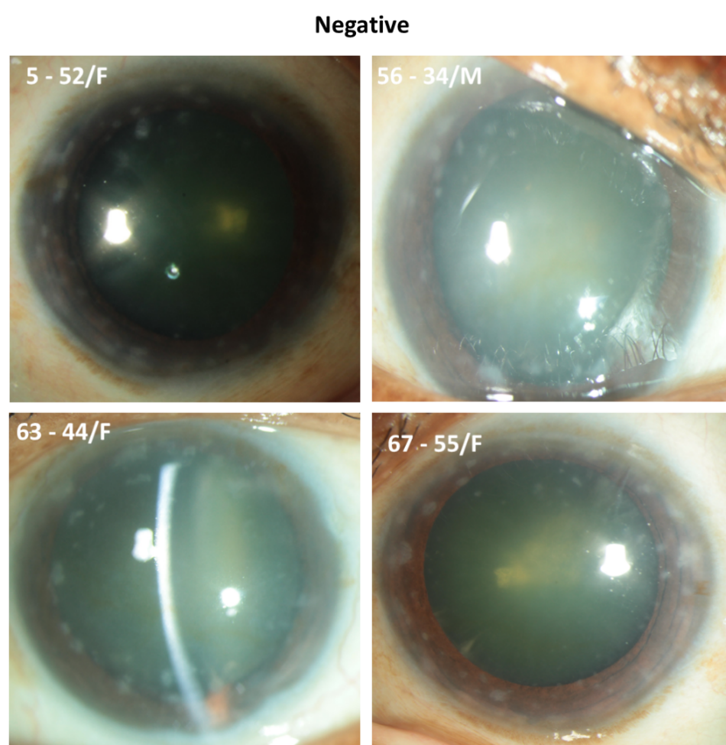
E

