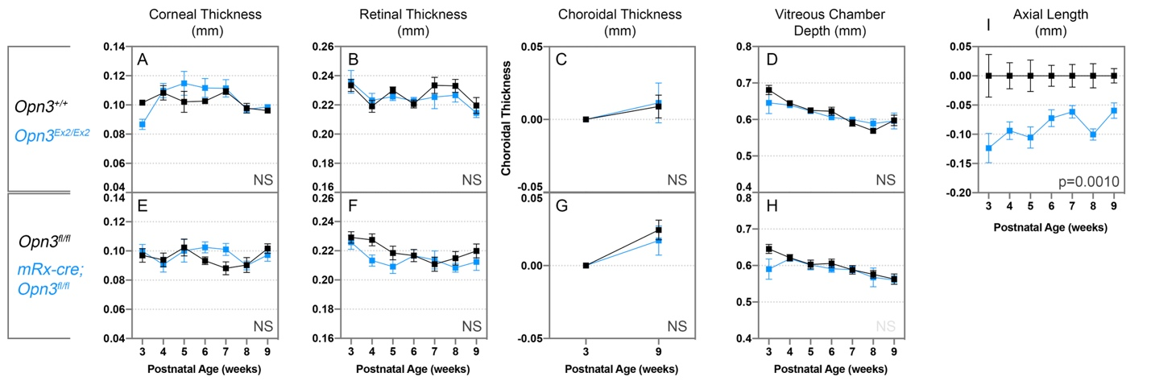

Supplementary Figure 2: Shortened Opn3^{Ex2/Ex2} axial length is not progressive. Ocular Biometry for mice of the Opn3^{Ex2/Ex2} (top row) and Opn3^{fl/fl}; mRx-cre genotypes (bottom row) including corneal thickness (A, E), retinal thickness (B,F), choroidal thickness (C,G), and vitreous chamber depth (D, H). Neither the Opn3^{Ex2/Ex2} (top, blue traces, n=5) nor the Opn3^{fl/fl}; mRx-cre (bottom, blue traces, n=10) show differences compared to control (top and bottom, black traces, n=4 and 11, respectively). (I) Replotted axial length of Opn3^{Ex2/Ex2} and controls normalized to the control average. The difference between Opn3^{Ex2/Ex2} and control axial length decreases with time. Statistical significance was assessed using a two-way ANOVA. NS: Not significant.

