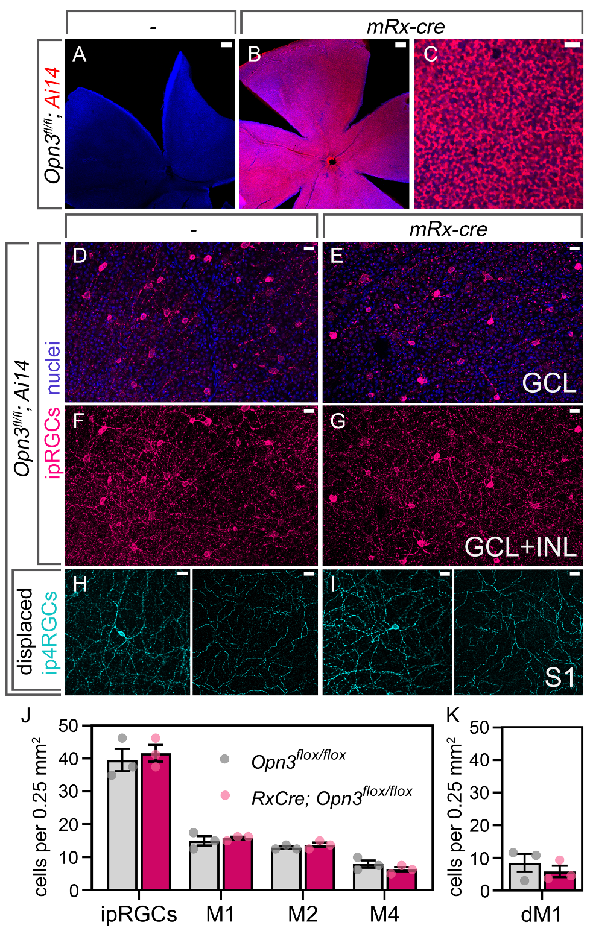

Supplementary Figure 1: Conditional deletion of retinal Opn3 does not alter OPN4 RGCs numbers.
(A-C) Images of whole mount retinae from P60 mice of the genotypes Opn3^{fl/fl}; Ai14 (A, 200 µM scale bar) and Opn3^{fl/fl}; Ai14; mRx-Cre (B, low magnification, 200 µM scale bar; C, high magnification, 25 µM scale bar) showing that mRx-cre is active in most retinal neurons. (D-I, 25 µM scale bars) Images of OPN4 labeled whole mount retinae from Opn3^{fl/fl}; Ai14 (D, F, H) and Opn3^{fl/fl}; Ai14; mRx-Cre (E, G, I) within the ganglion cell layer (GCL)(D, E), the GCL and inner nuclear layer (GCL+INL)(F, G) and in the S1 lamination of the inner plexiform layer (S1)(H, I). These images show qualitatively that the number of OPN4 RGCs appears unchanged when Opn3 is conditionally deleted. This is confirmed with quantification of all OPN4 RGCs (J, ipRGCs), the M1, M2 and M4 subtypes (J, M1, M2, M4) as well as the displaced M1 OPN4 RGCs (dM1) within the inner plexiform layer (K). n=3 for all biological replicates.

