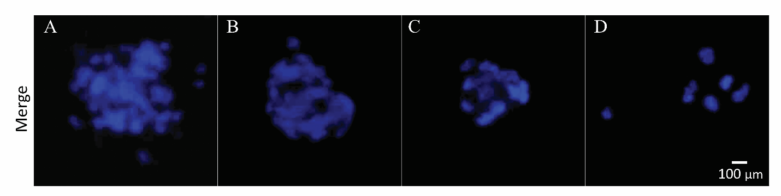Fig. S2 - Negative and background controls for immunostaining assays. (A), (B), (C) and (D): Merged of DAPI and FITC photographs of hRPE cells that had been recruited in immunostaining assay without primary rabbit anti-human, mouse anti-human and goat anti-human antibodies and without applying primary and secondary antibodies, respectively. Magnification: 200X

