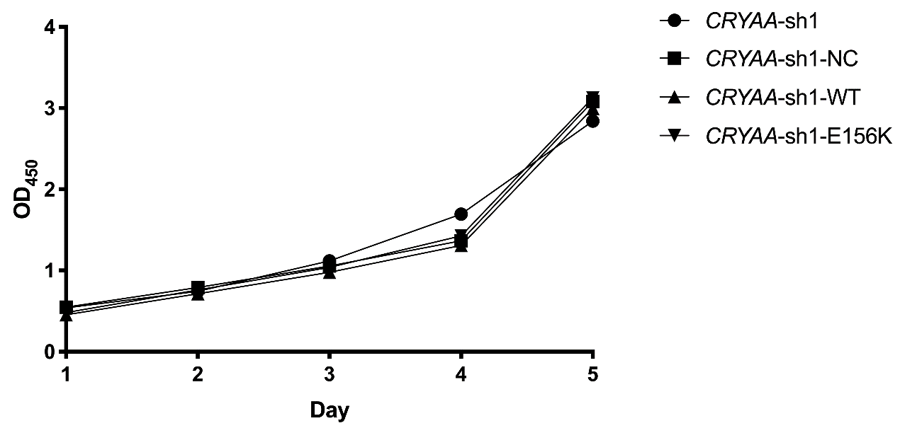
Supplementary Figure S2. CCK8 assay results showed no significant difference in cell proliferation between wild-type and E156K CRYAA.

