Figure S1
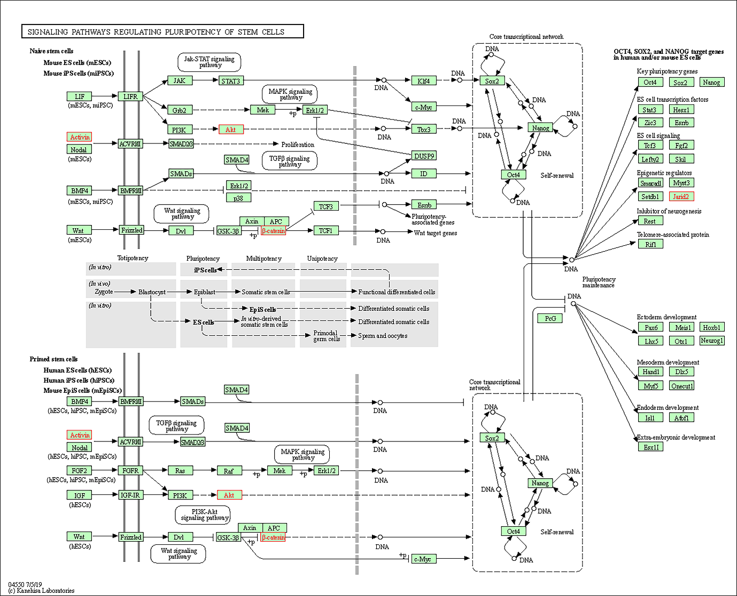
Figure S1 Pathway analysis of hsa-miR-150-5p predicted targets
The figure represents the KEGG pathway analysis of hsa-miR-150-5p predicted targets associated with the pathways regulating pluripotency of stem cells. The targets of hsa-miR-150-5p are represented in red box.

