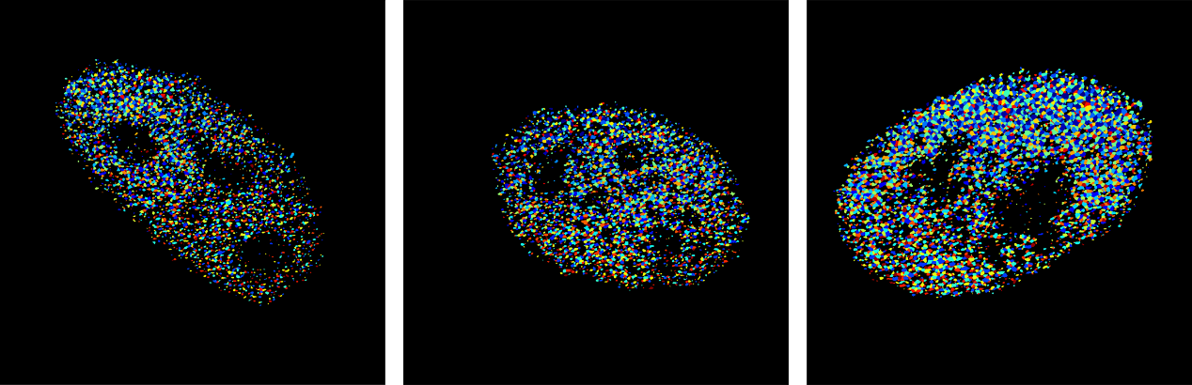
Figure S4. 5hmC nanocluster imaging analysis using CellProfiler. Segmented 5hmC nanoclusters of cells shown in Fig. 3a. 5hmC clusters were thresholded with the otsu-three-class method, then segmented based on intensity distributions. Then cluster morphology and neighboring, and intensity distribution features were measured accordingly.

