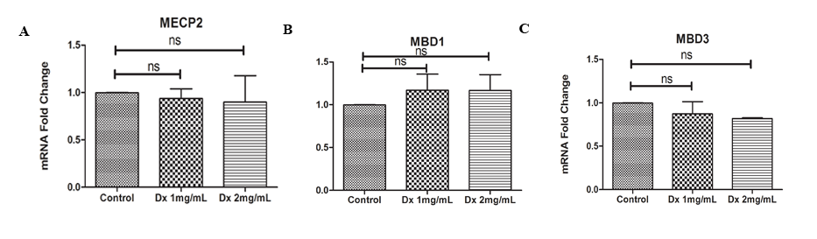
Figure S3. DEX exposure did not alters methyl-binding-domain related mRNA expression level. The transcription level of (A) MeCP2, (B) MBD1, (C) MBD3 was determined by qRT-PCR after 48 hrs of DEX exposure. n=3 (mean ± s.d.).

