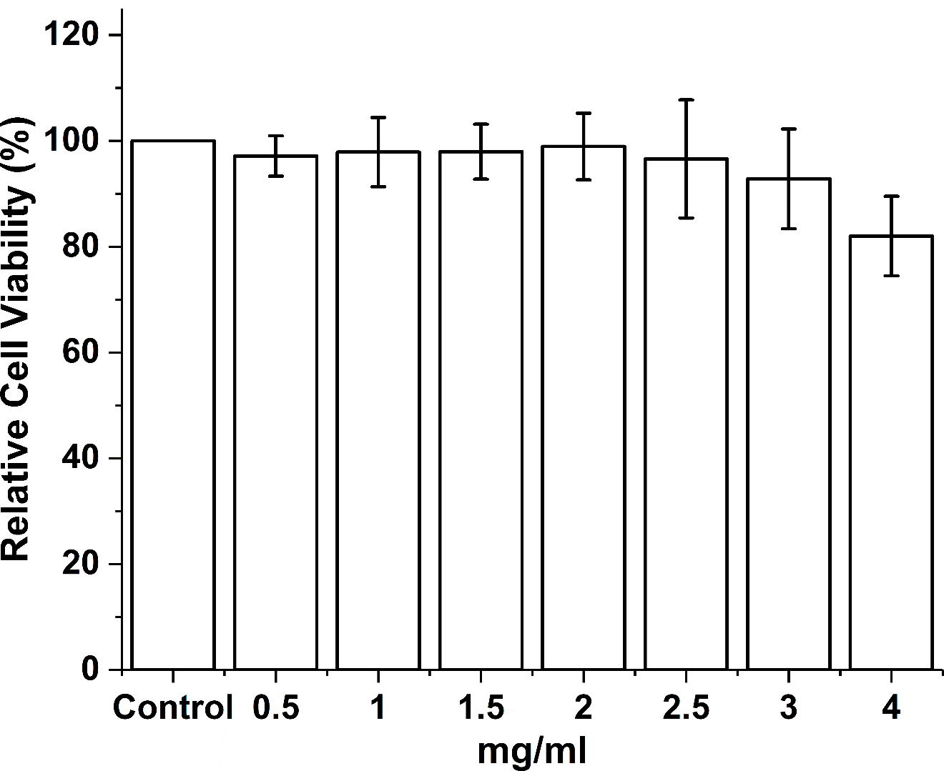
Figure S2. MTT assay of ARPE-19 cells under different DEX exposure level after 48 hr. Data shown as mean ± s.d. n =3

