Supplementary Information
Epigenetic alterations associated with Dexamethasone sodium phosphate through DNMT and TET in retinal pigment epithelium cells
Wenjie Liu^{1, 2}, Sruthi Priya Mohan³, Nareshkumar Ragavachetty Nagaraj³, Shyam Sundar Jaganathan³, Yi Wen^{1, 2}, Sharada Ramasubramanyan³, *Joseph Irudayaraj^{1, 2}

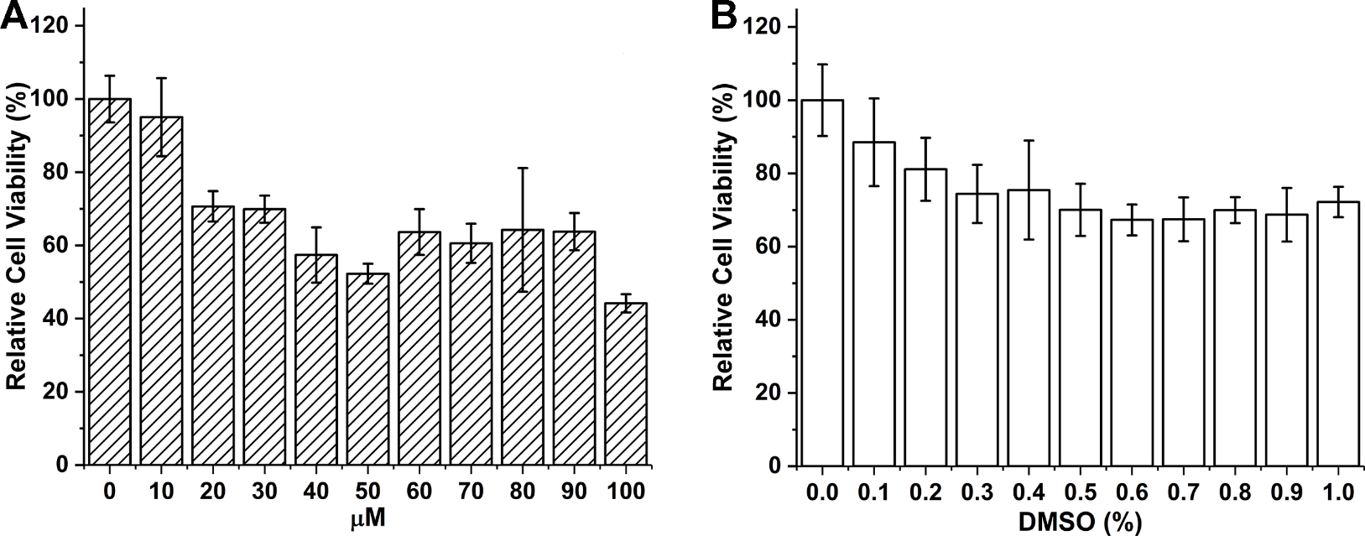
Figure S1. MTT assay of Dexamethasone and respective DMSO %. After 48 hr exposure. (A) Relative cell viability of ARPE-19 cells under various concentration of Dexamethasone exposure. (B) Relative cell viability of ARPE-19 cells under corresponding DMSO vehicle control exposure. n=4. Data shown as mean ± s.d.

