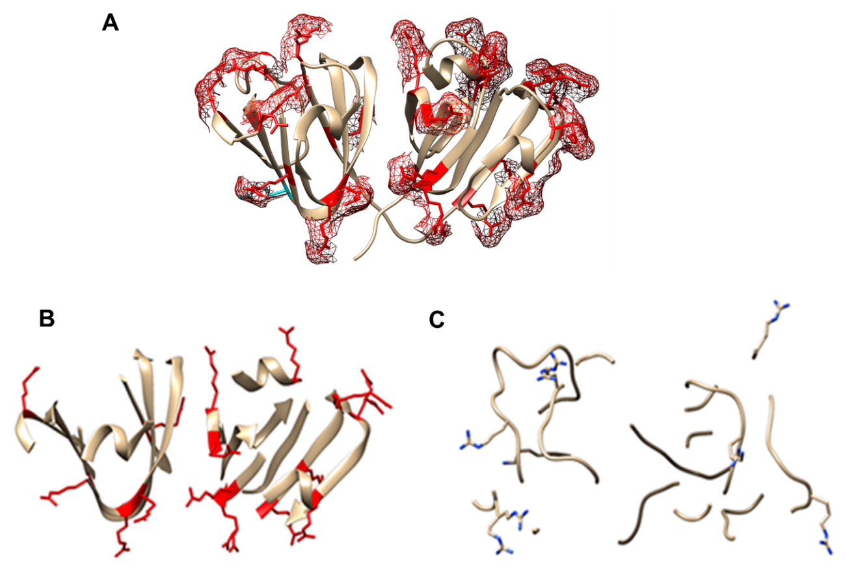
Figure S2. Representation of arginine and lysine on the crystal structure of γD-crystallin protein.
(A) Mesh shows all the residues (arginine - red and lysine - cyan) in γD-crystallin protein are exposed to the solvent; (B) Fifteen arginine residues (red) are present on the α-helix and β-sheet; (C) Six arginine and one lysine residues are present on the β-turn (blue) (http://www.cgl.ucsf.edu/chimera, PDB ID 1HK0).

