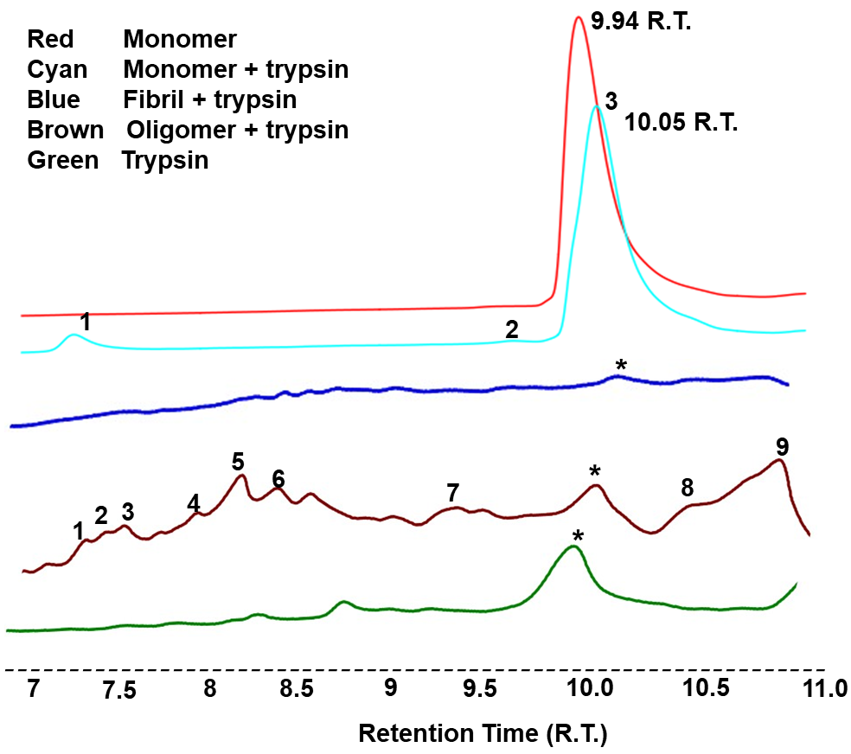
Figure S1. RP-HPLC chromatograms obtained after digestion of monomers, oligomers and fibrils with trypsin.
(∗ Indicates peak of enzyme trypsin, in monomers (cyan), trypsin peak was not visible due to more peak area of the fragment obtained after digestion, at same R.T. of trypsin).

