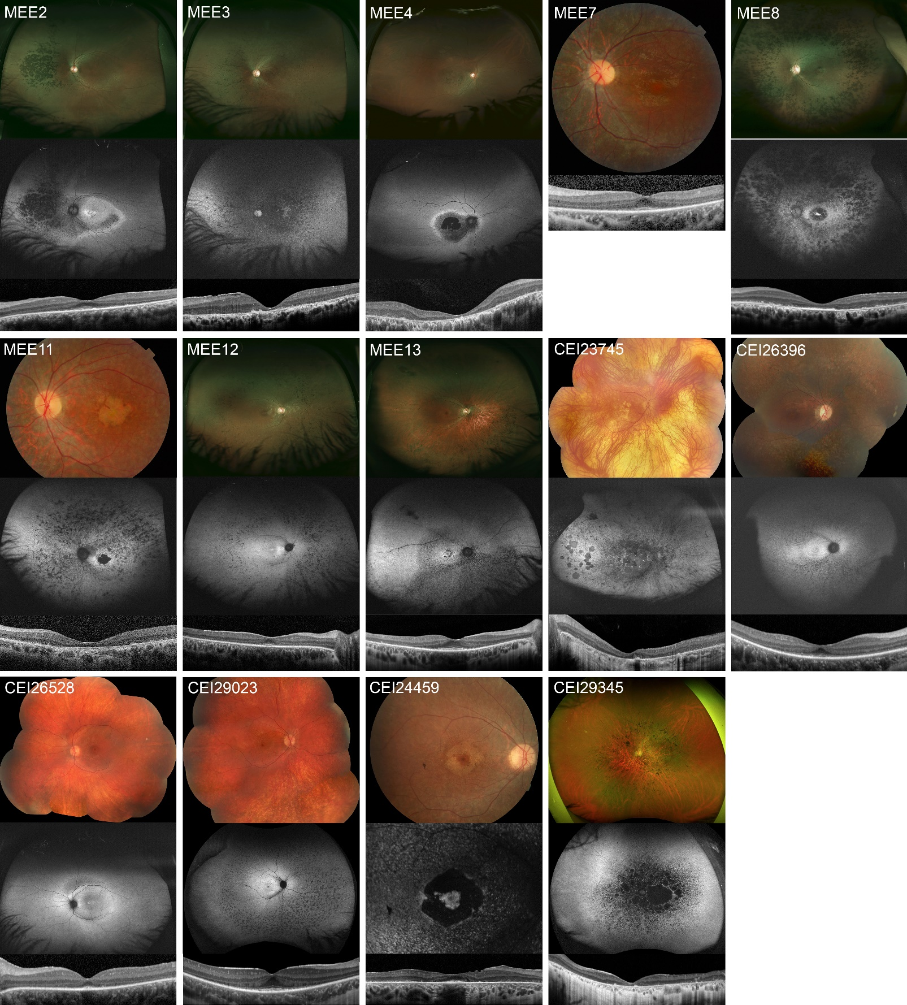
Appendix 6: Retinal imaging from patients with biallelic RP1-associated retinal dystrophies

Imaging for each patient includes fundus photography (top image), fundus autofluorescence (middle image; not available for MEE7), and OCT (bottom image). Retinal imaging was limited in quality for MEE10 due to cataract and is not presented. For other patients, imaging is from the age of first exam noted in Appendix 3 with the following exceptions: M11 (ages 25-27), CEI23745 (fundus photo age 30; other imaging age 42), CEI24459 (age 26). An incidental operculated hole is visible in the imaging for MEE13.

