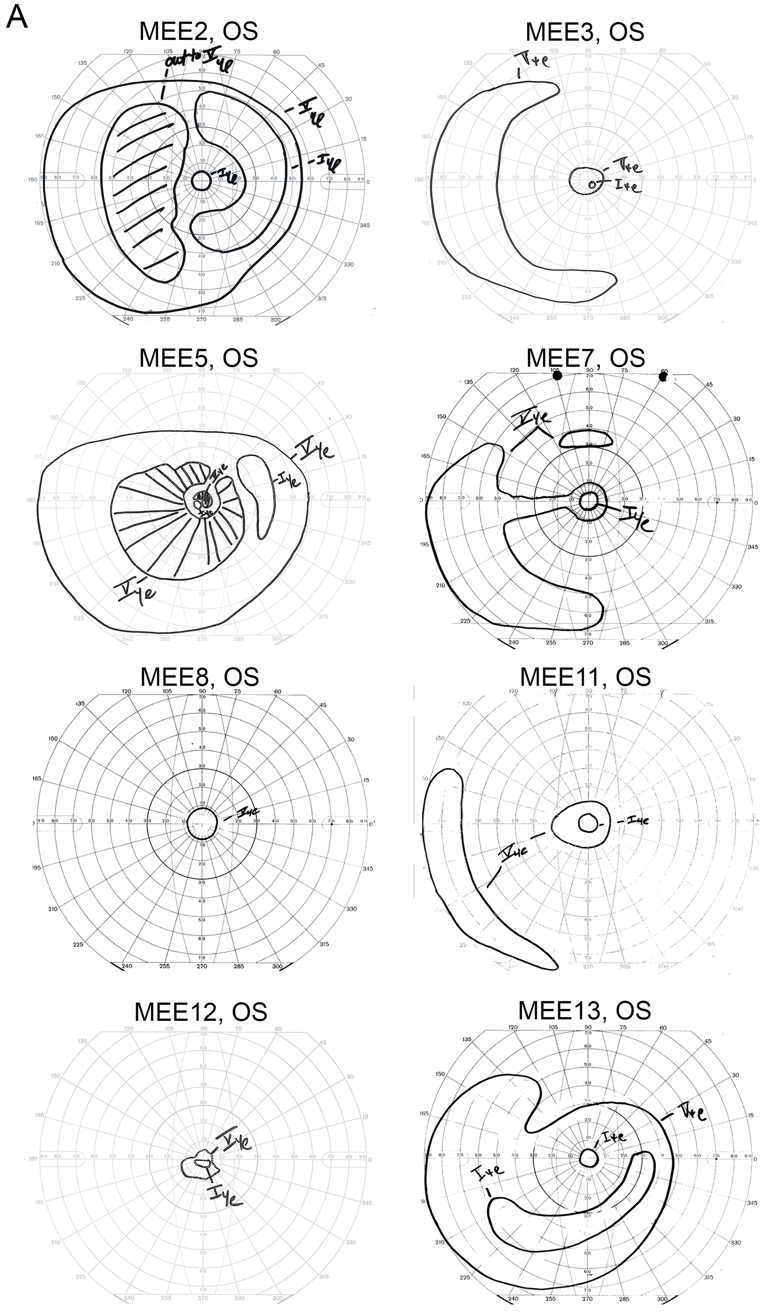
Appendix 4: Visual fields of patients with biallelic RP1-associated retinal dystrophies
A
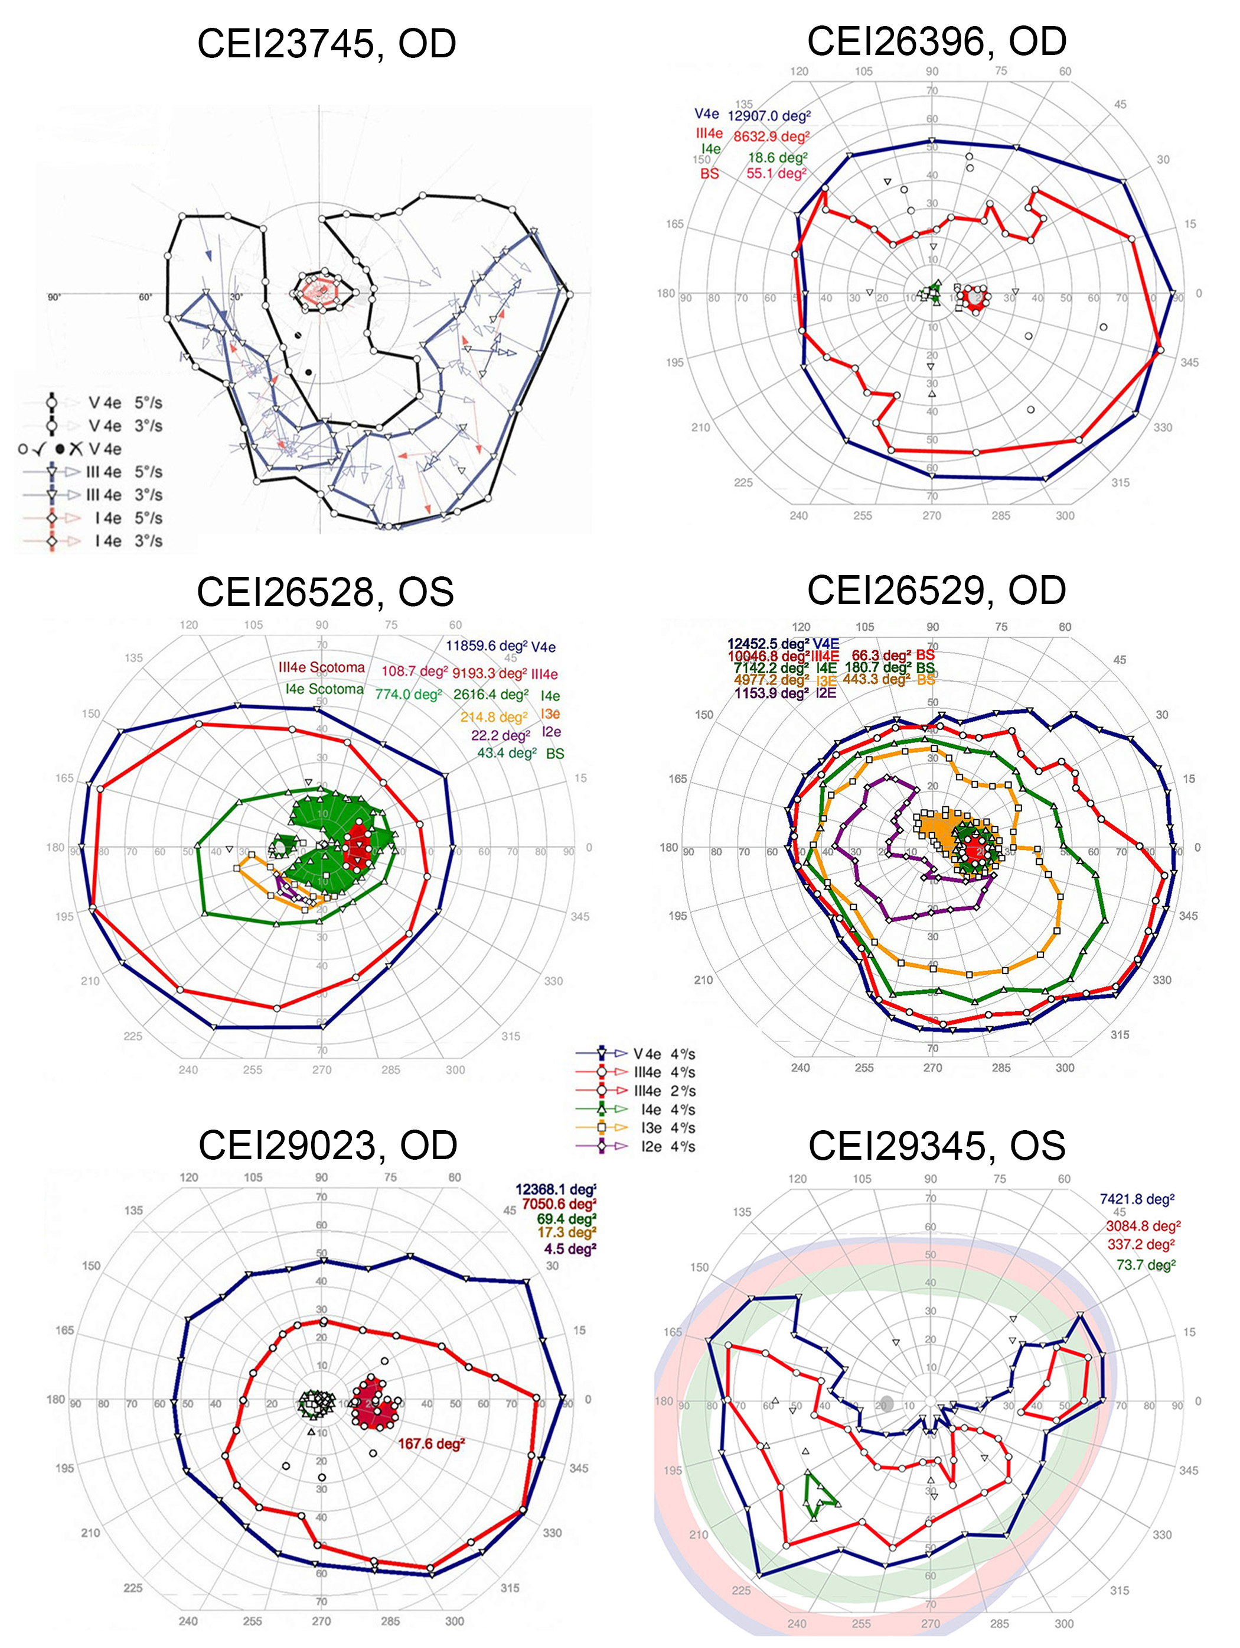
B

The results of Goldmann perimetry (A; MEE patients) and Octopus kinetic perimetry (B; CEI patients) are shown for patients for whom visual fields of adequate digital quality were available. Visual fields correspond to the eye for which imaging is shown in Figure 2 and Appendix 6 with the exception of patient MEE13. Perimetry was performed at the age noted in Appendix 3.

