Appendix 5. Optimization of MIPs based enrichment and Sanger sequencing confirmation
Figure S1. Optimization by justifying concentration of each probe.
The main challenge of MIPs based enrichment is the low uniformity of capture, which is largely due to the low capture efficiency for those regions with extremely low or high GC content. In this study, several optimizations were employed to improve the efficiency and uniformity of capture. Firstly, we justified the concentration of each probe according to the read accounts of capture region. Secondly, to increase the efficiency of hybridization, we sheared genomic DNA into small fragments (about 300-500bp) before the hybridization of MIPs. A. the depth distribution for the capture with probes at equimolar concentration; B. the depth distribution for the capture with probes after justifying concentration; C. Representative genome images from the Integrated Genome Viewer (IGV) for MIP-based panel sequencing.
Figure S2. Variants confirmation by Sanger sequencing
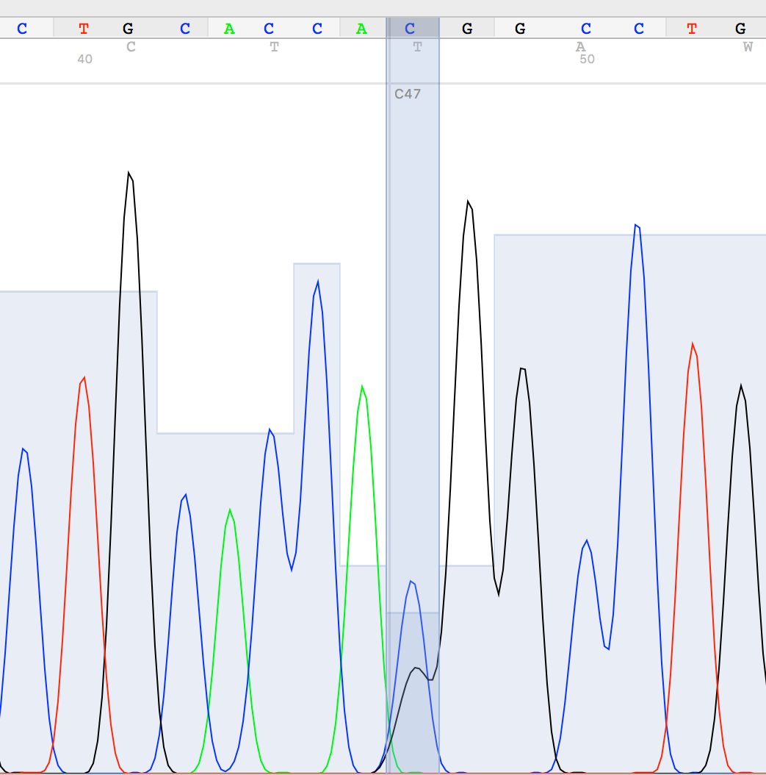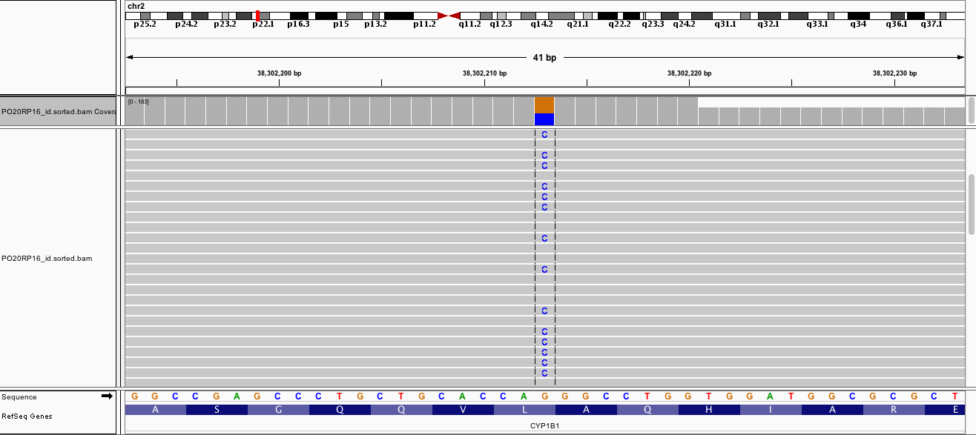
PO20RP16-CYP1B1-L107V
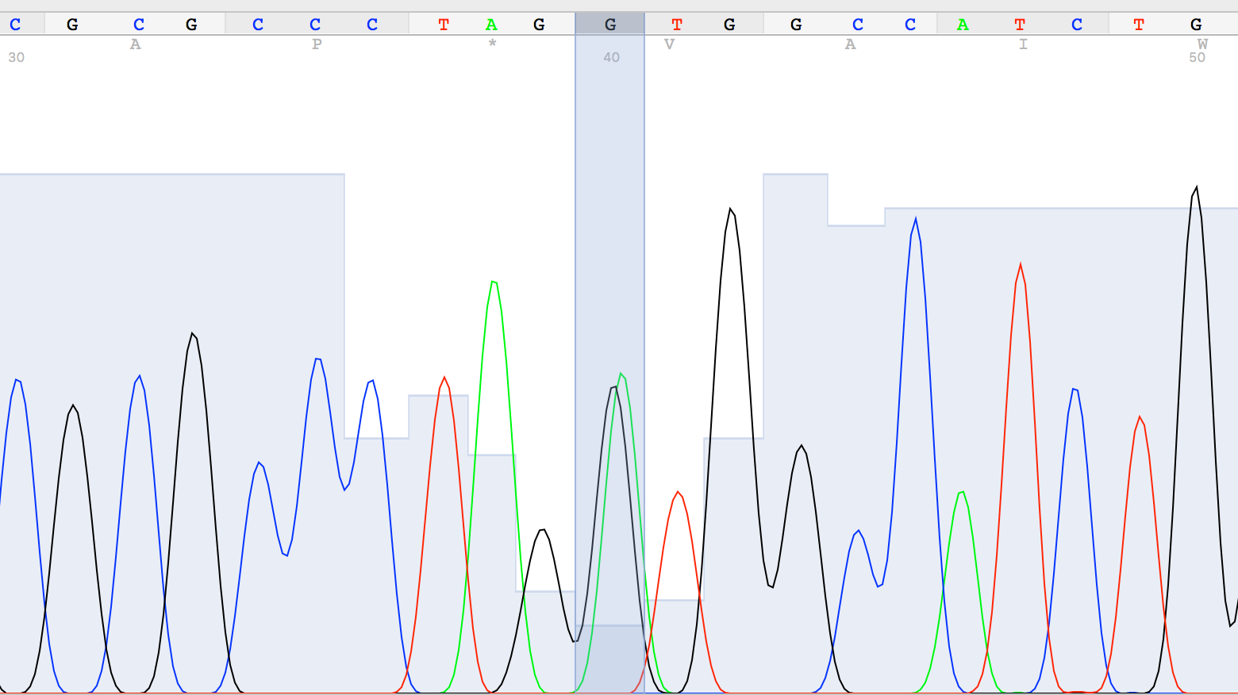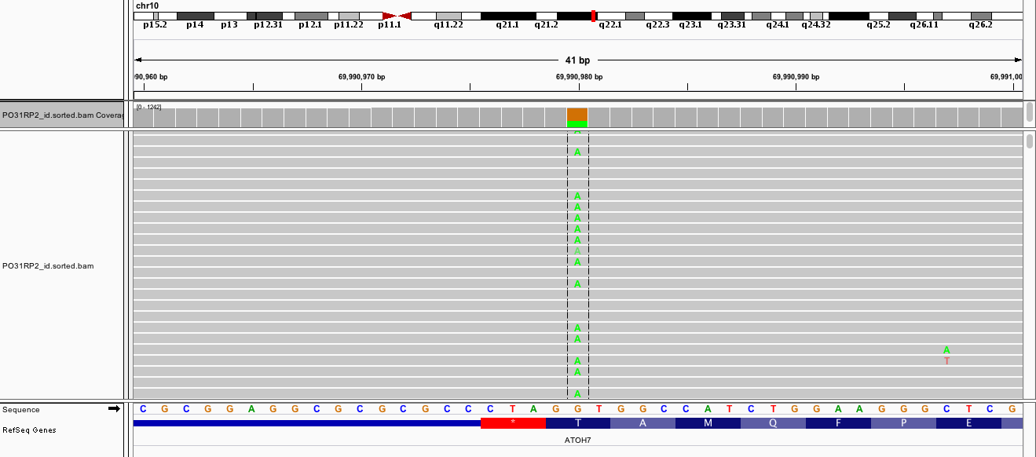
PO31RP2-ATOH7-T152I
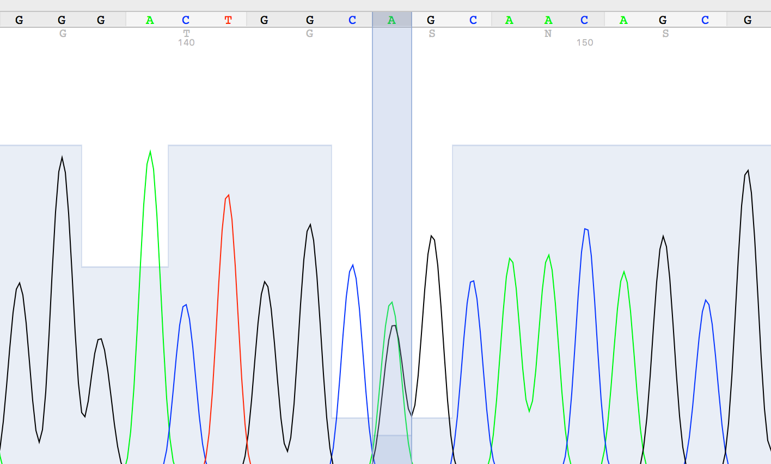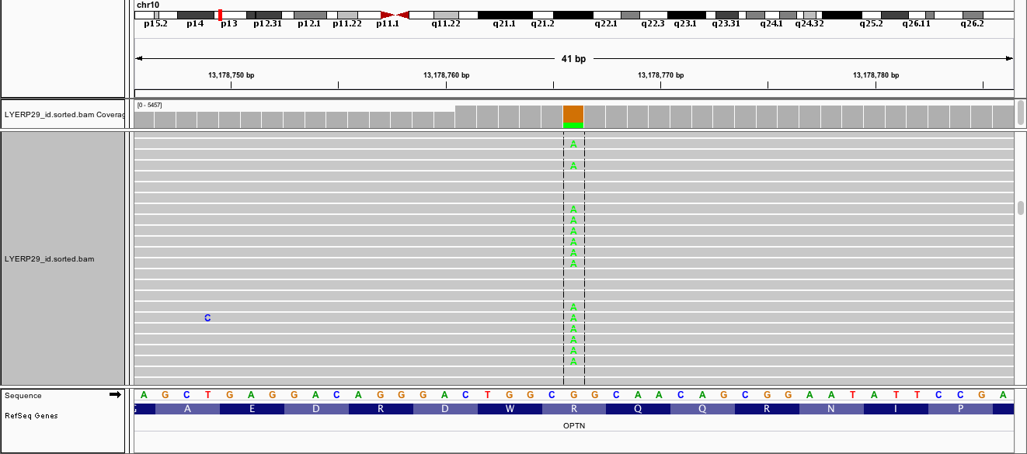
PO101RP12-OPTN-R545Q
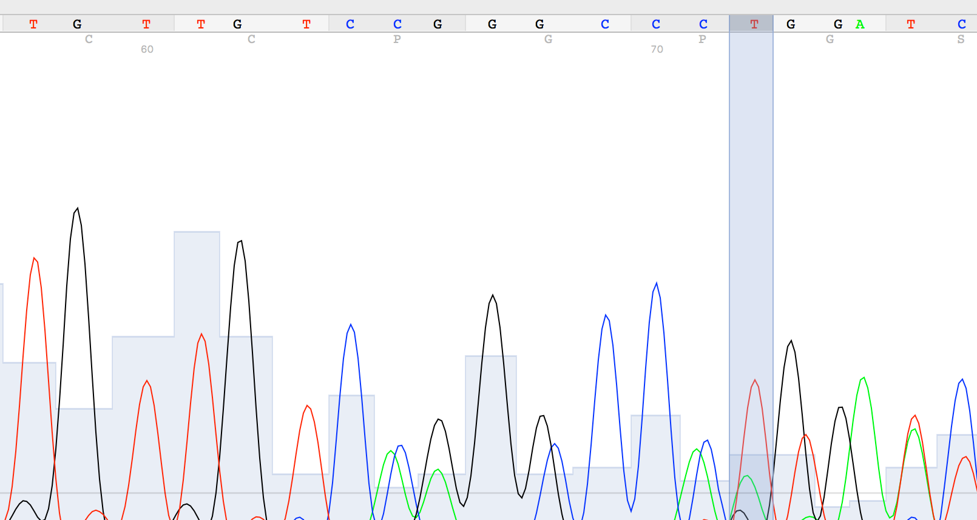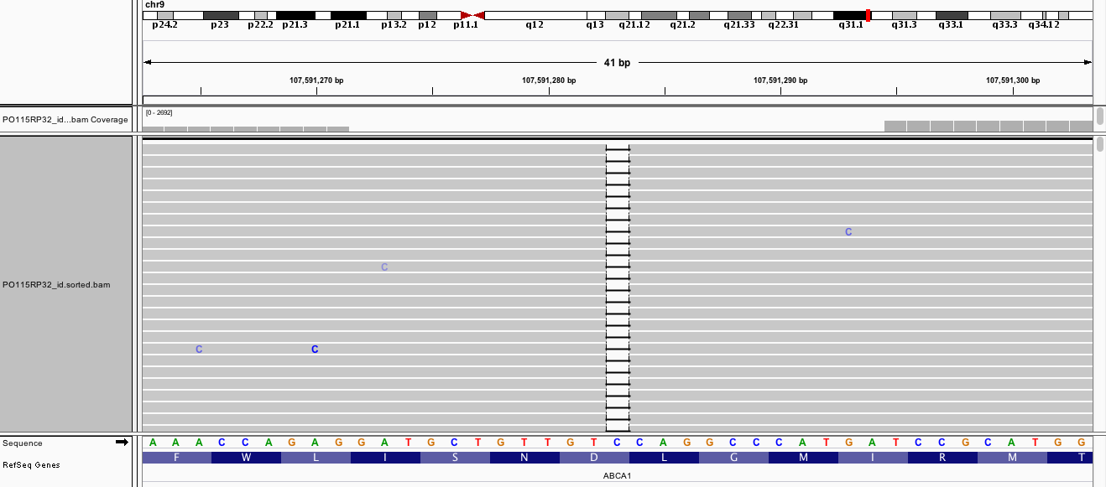
PO115RP32-ABCA1-D677fs
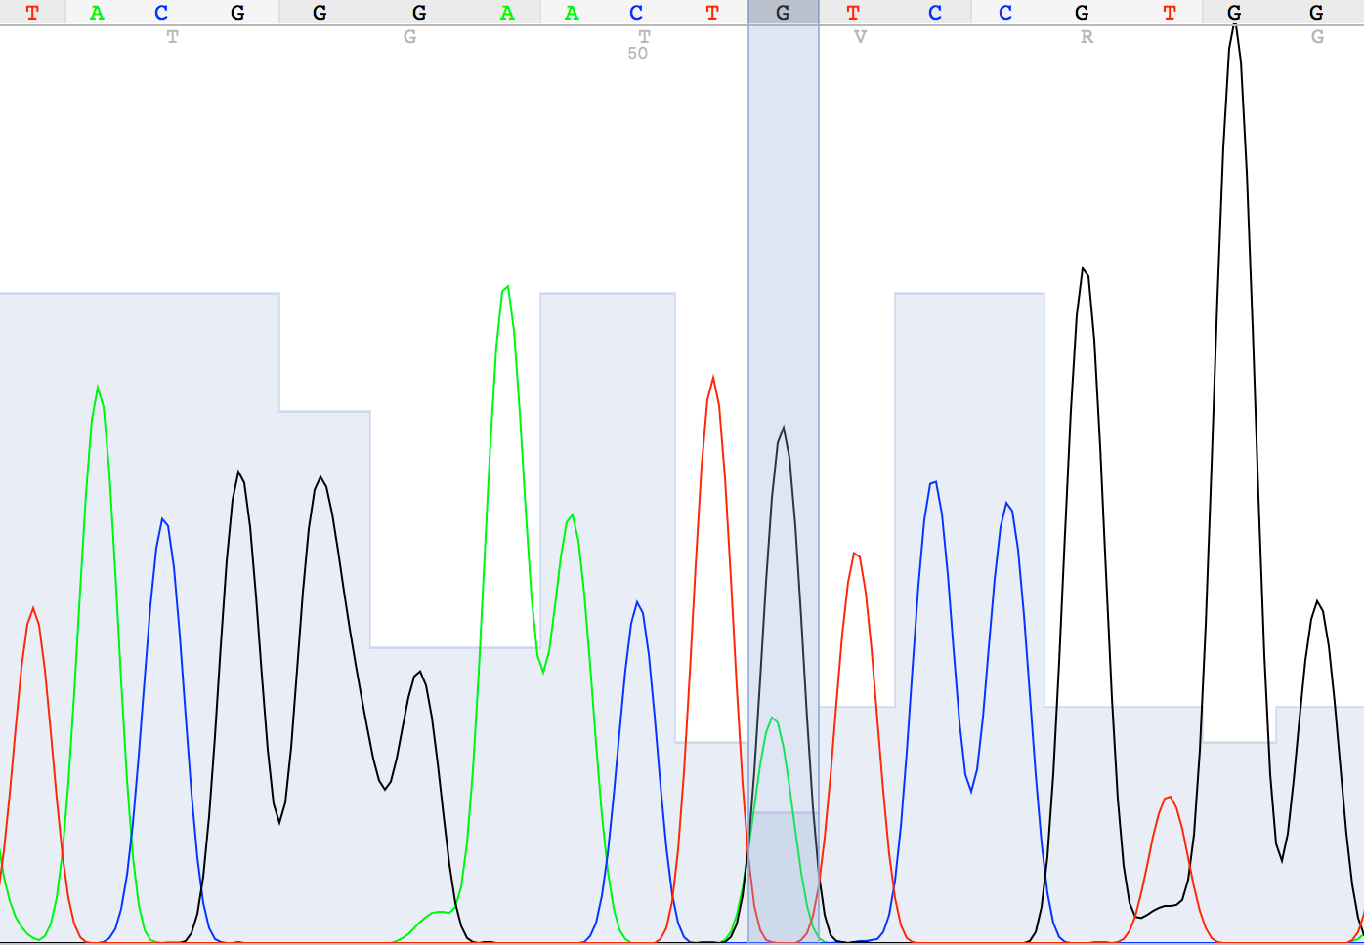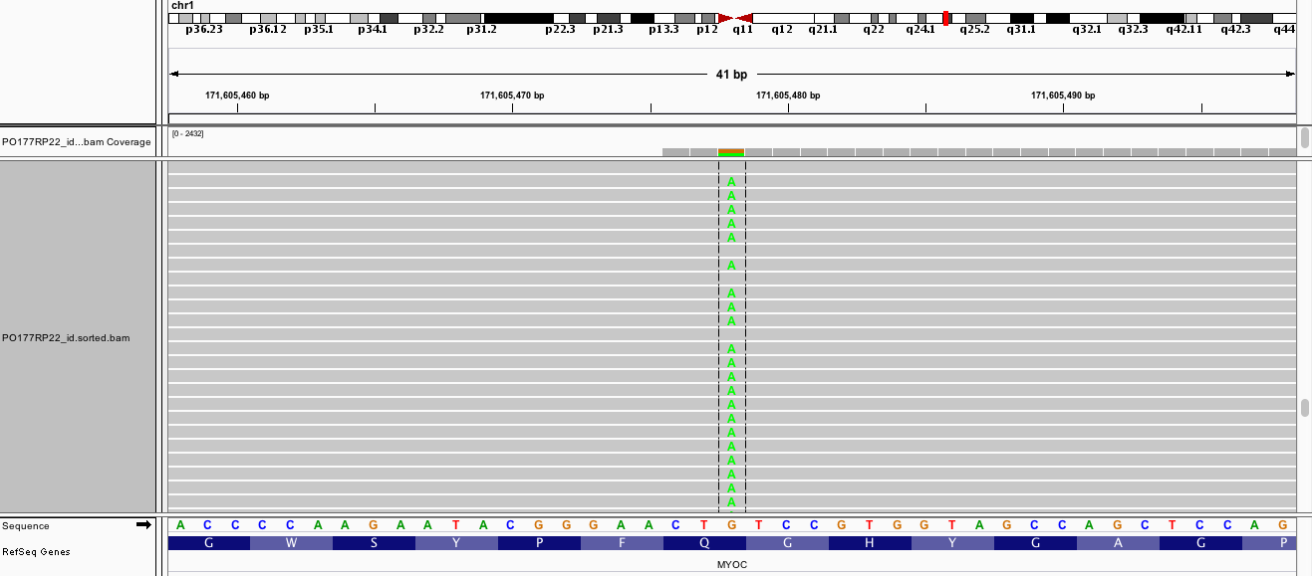
PO117RP22-MYOC-Q368X
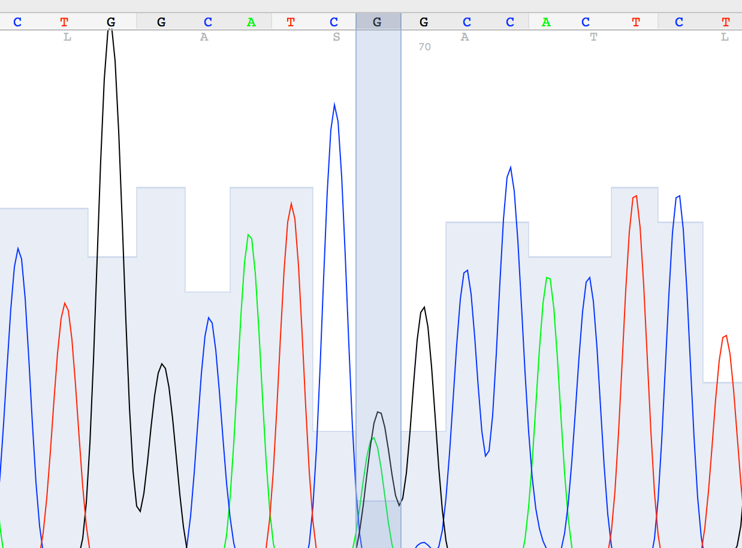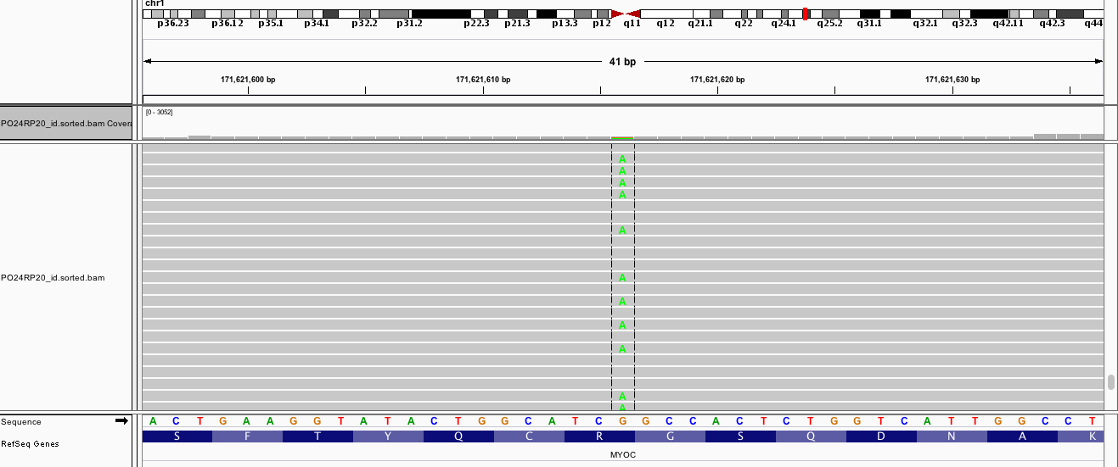
MYOC-R46X
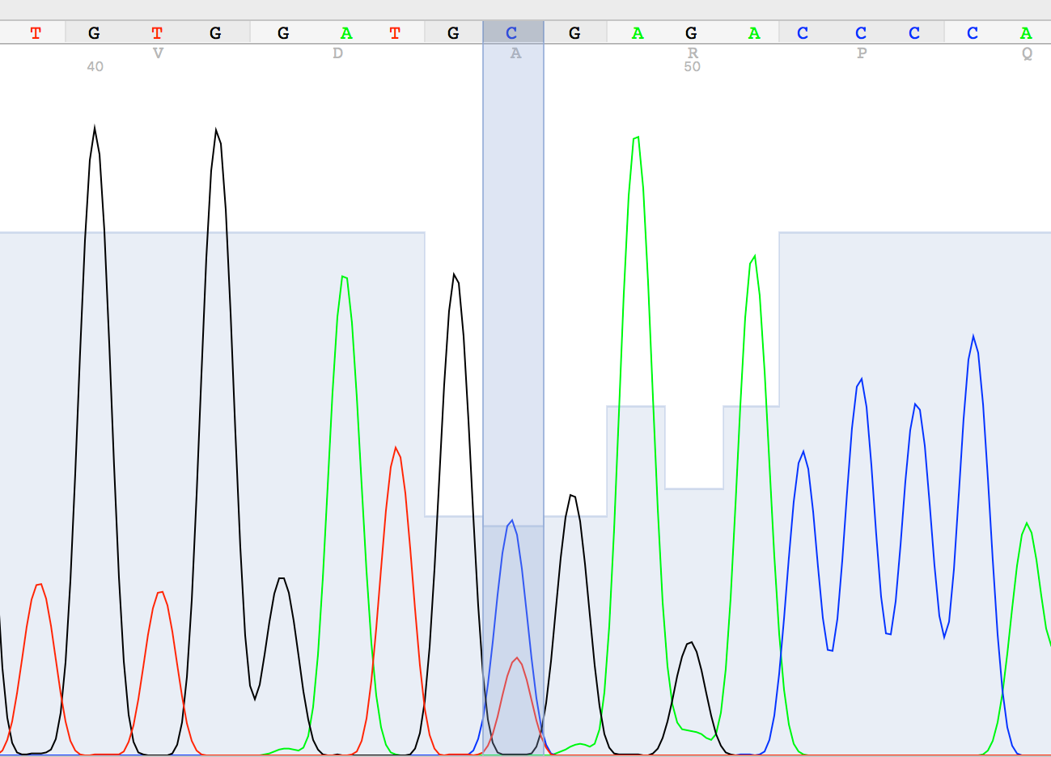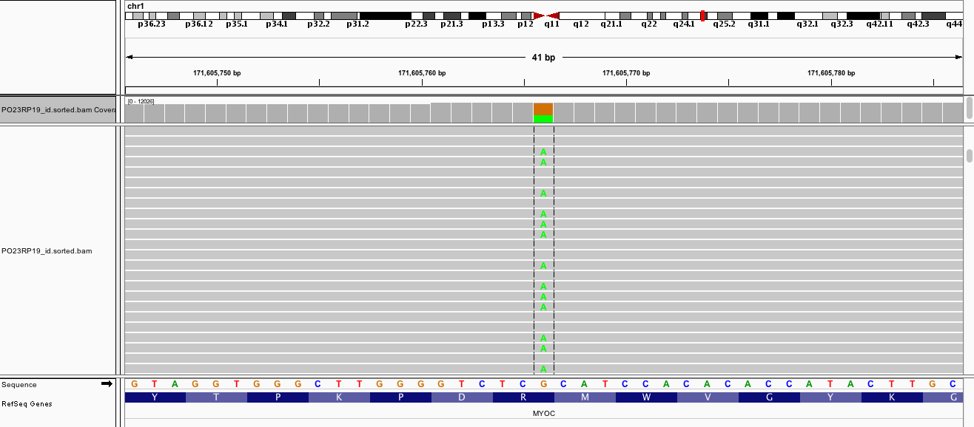
MYOC-R272X
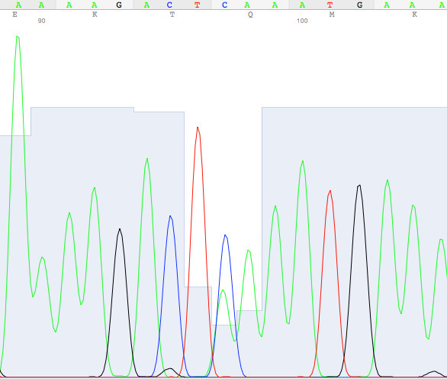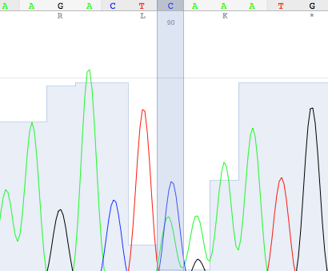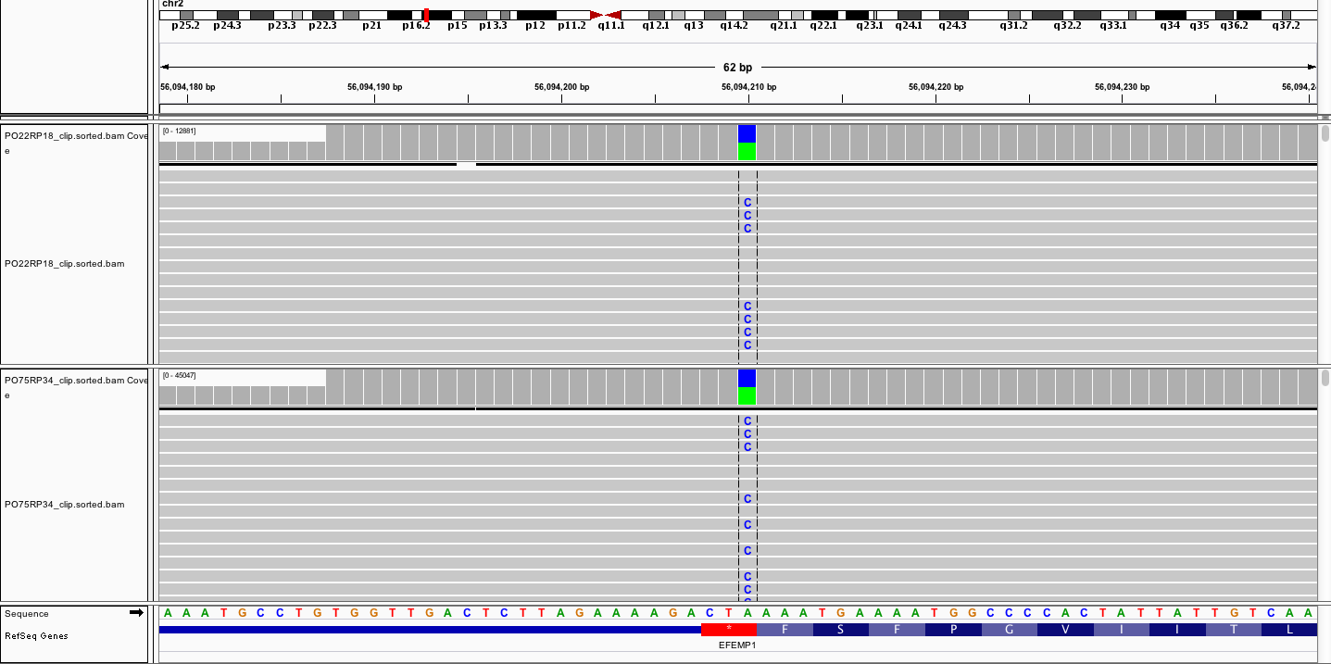
EFEMP1-X494E

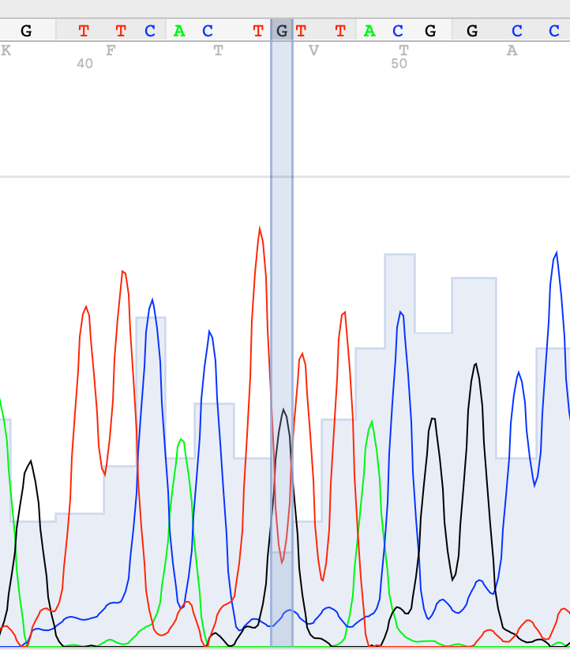
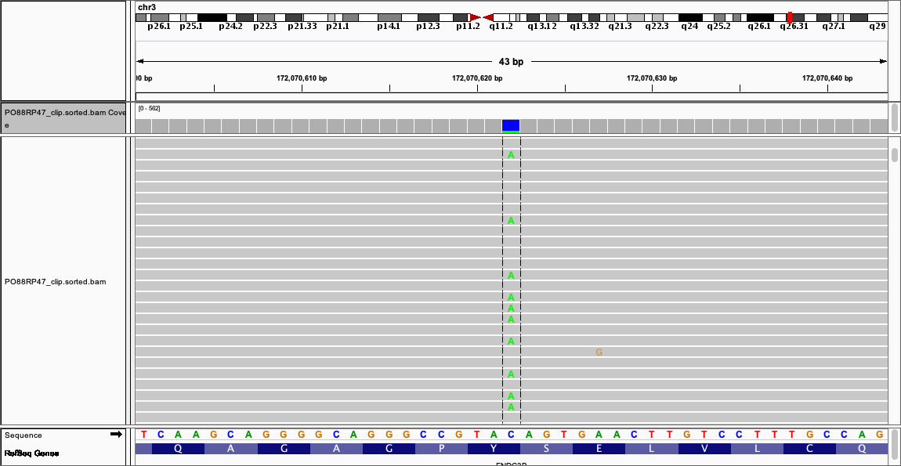
S267fs in APOE
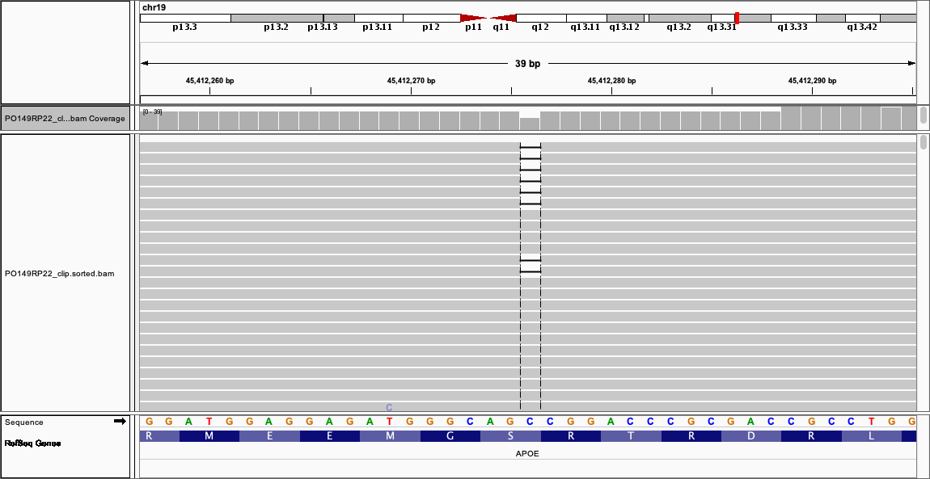
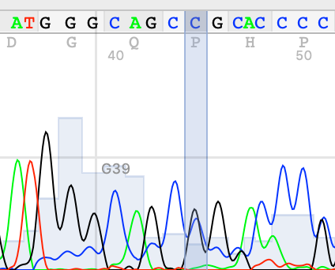
Y848X in FNDC3B
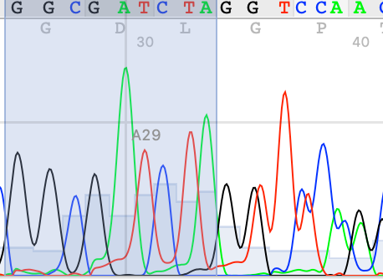
G77fs in CDKN2B
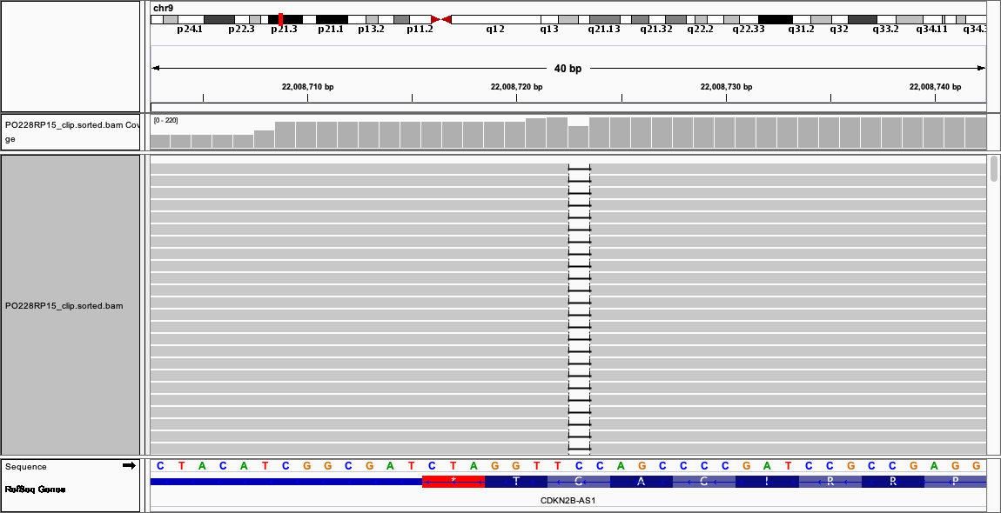
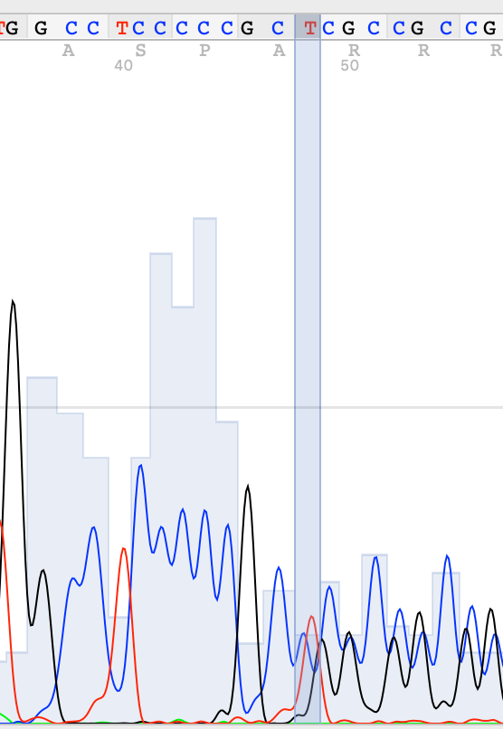
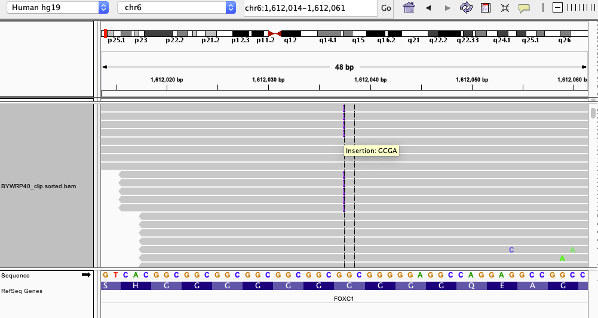
G453fs in FOXC1

