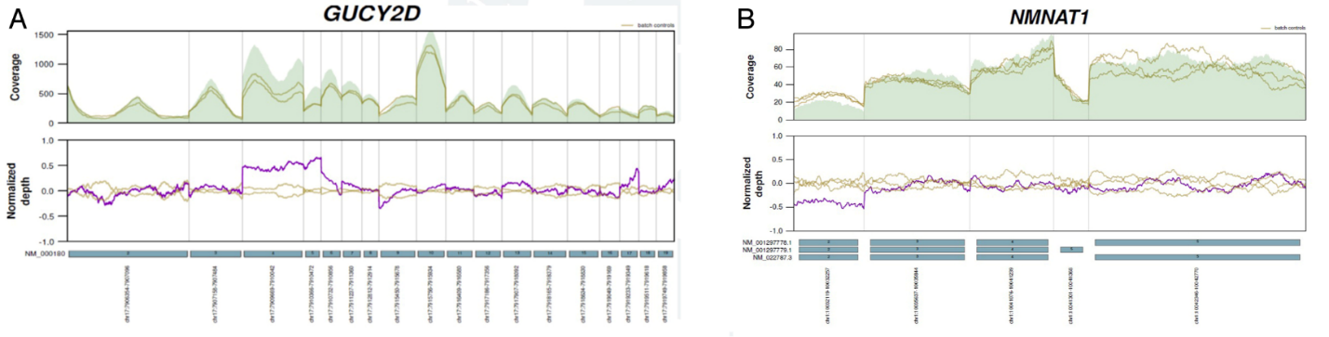

**APPENDIX 7. Detailed analysis of copy number variants (CNVs) in Korean patients with Leber congenital amaurosis.** (A) Exon 4–5 duplication of *GUCY2D* occurred *de novo* in P20. (B) Deletion of exon 2 of *NMNAT1* in P30. Only heterozygous c.709C>T variant in *NMNAT1* was found before analyzing CNVs.