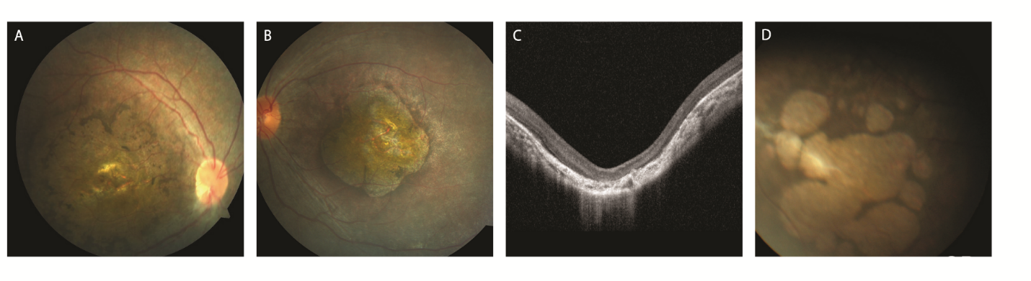
APPENDIX 6. Typical macular colobomatous degeneration of NMNAT1 patient and distinct “multiple colobomatous” retinal degeneration in a patient with novel NMNAT1 variant. (A) Fundus photograph of 4-year-old patient (P27) carrying c.196C>T and c.709C>T variants in NMNAT1. Typical early coloboma-like macular degeneration was observed. (B, C) Fundus photograph and OCT image of another 4-year-old patient (P48) carrying NMNAT1 c.709C>T mutation. OCT image shows staphyloma-like posterior bowing of the macula and choroidal thinning underneath. No second mutation was found by targeted next-generation sequencing (D) Fundus photographs of 3-year-old patient carrying c.275G>A and c.709C>T variants in NMNAT1. (P22) c.275G>A:p.(Trp92*) nonsense mutation in NMNAT1 causes multiple “bear-foot like” colobomatous macular degeneration, which was distinct from other patients with NMNAT1 mutations.

