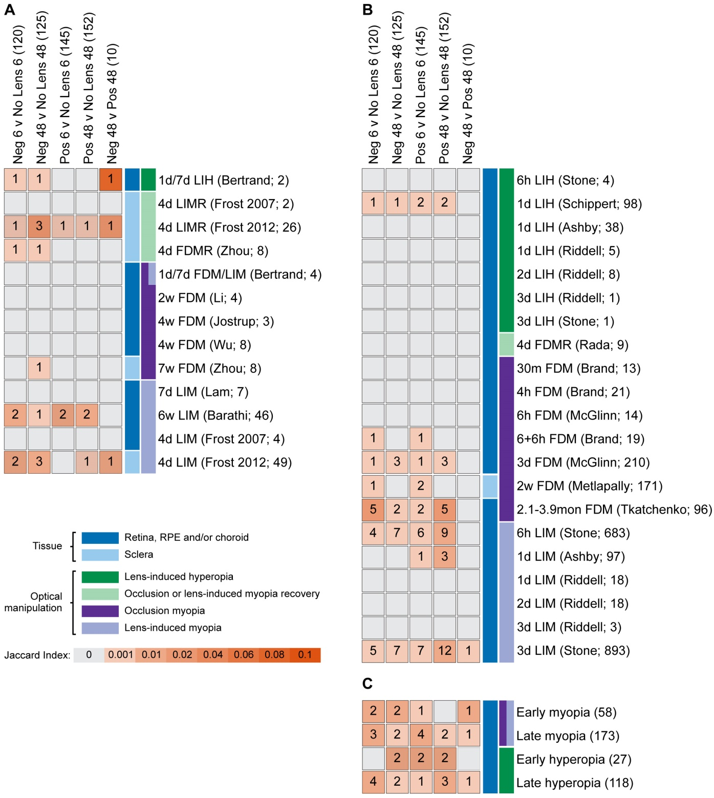
Appendix 8. Comparison of single protein findings with past exploratory proteomic and transcriptome studies of refractive error. (A) Table showing the number of common findings between the present study and past exploratory proteomics studies of optically-induced refractive error. (B) Table showing the number of common findings between the present study and past exploratory transcriptome studies of optically-induced refractive error. (C) Table showing the number of common finding between the present study and past meta-analyses of chick refractive error transcriptomes. The number of genes or proteins in each list is shown in parenthesis after the list name. Note that human orthologs could not be identified for some of the differentially abundant proteins in the present study. The Jaccard Index is the size of the intersection divided by the size of the union of the sample sets. Abbreviations are as follows: Neg = Negative lens, Pos = Positive lens, m= minutes, d= days, w= weeks, mon= months, LIH= Lens-induced hyperopia, LIM= Lens-induced myopia, FDM= Form deprivation myopia, LIMR= LIM recovery, FDMR= FDM recovery, RPE = Retinal Pigment Epithelium.

