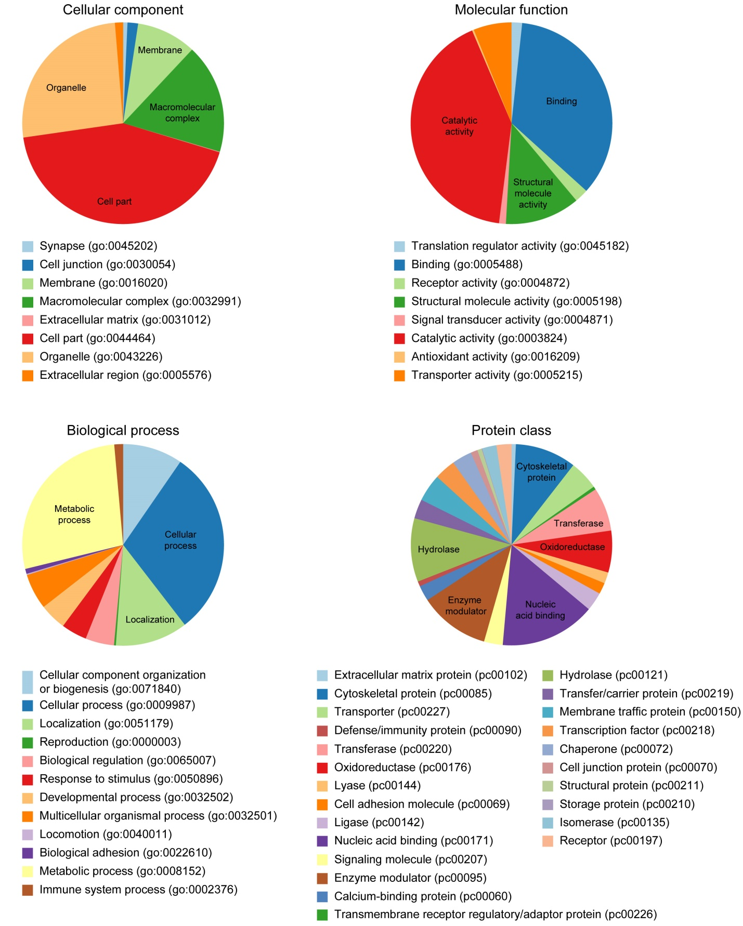
Appendix 1. PANTHER Gene Ontology (cellular component, molecular function, and biological process) and protein class classifications for the 1617 proteins in the filtered LC-ESI-MS/MS chick retina/RPE dataset.

