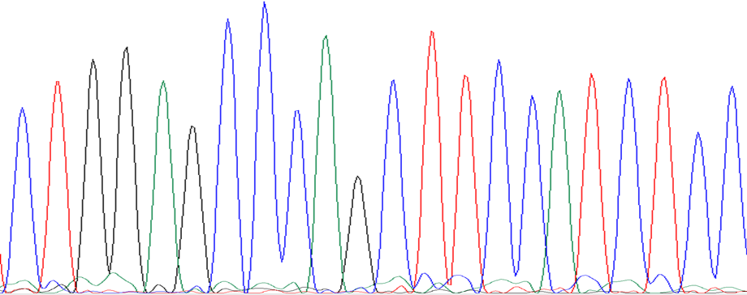
C T G G A G C C C A G C T T C C A T C T C C
Reference sequence

c.485delC (p.Pro162Glnfs*24)

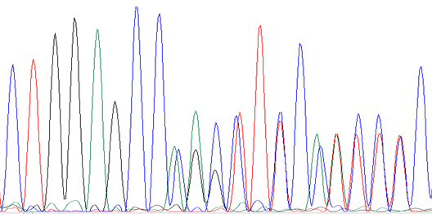

Appendix 3: Sanger sequencing of the OTX2 gene detected the deletion c.485delC (p.Pro162G.Infs*24) in exon 5 of OTX2 in a patient with early onset retinal dystrophy with atypical maculopathy.
Primers used for sequencing of Exon 5 of OTX2 are:
F: agctgatctgcccatgtagg R: CTAAGGCCCTTCGTTTTTCC

