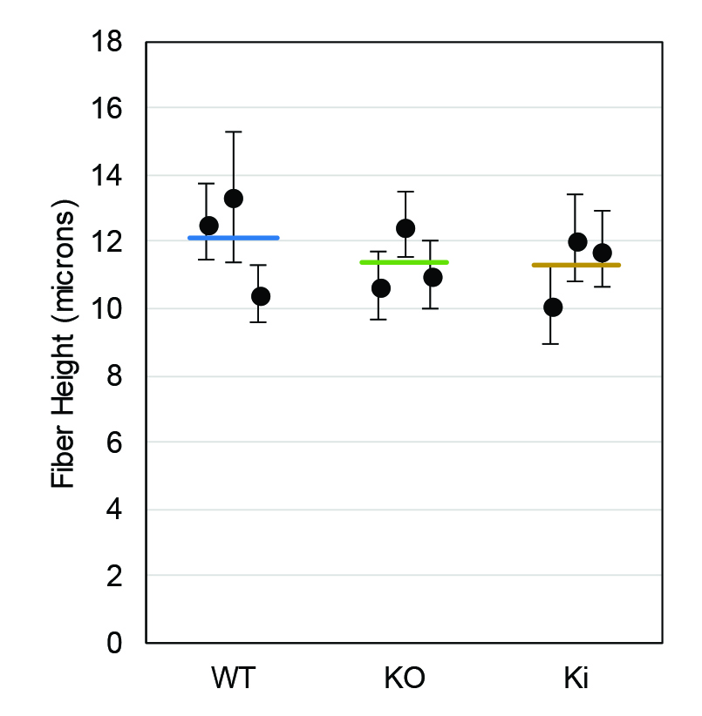
Supplementary Figure 2. 8-wk-old fiber cell long-side widths. The mean fiber cell long-side widths (circles) for each of three samples from WT, Cx50 KO, and Ki lenses. Error bars denote standard deviations. Horizontal lines denote the average of the three sample averages for each genotype. One-way ANOVA suggests no significant differences in average fiber width between the three genotypes (P > 0.6).

