Supplementary Material
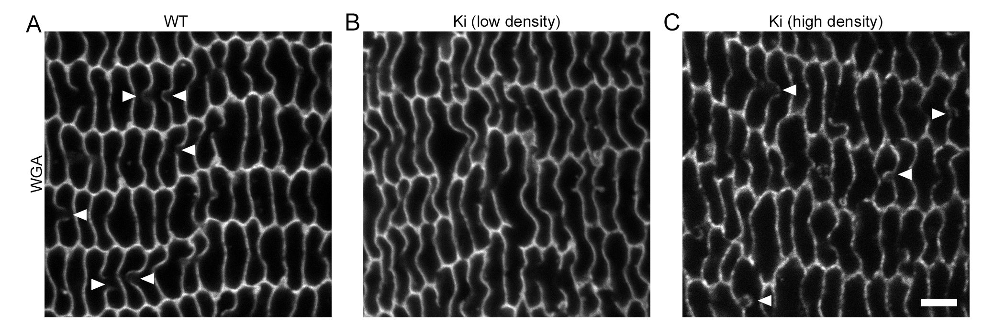
Supplementary Figure 1. Identification of BS with WGA-labeling. (A) BS are identifiable in WT samples as regions of weakened WGA staining where one fiber appears to bulge into its neighbor. (B) Most regions of 3-wk-old Ki samples had very few obvious BS. (C) Limited regions of 3-wk-old Ki samples had higher densities of BS-like structures. Arrowheads denote BS. Scale bar: 5 μm.

