Appendix 3. Quantile-quantile plots of p-values for A) single variant test of all variants (with minor allele count >2) and B) SKAT gene-based test of all variants.
A
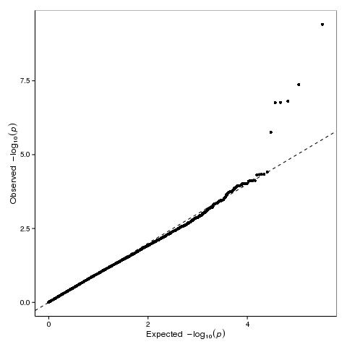

B
