Supplemental Figures
Supplemental Figure 1
Immunostaining pattern of sh-Kcnj10 expressing retinal explant
A. Schematic diagram of consructs used in this work
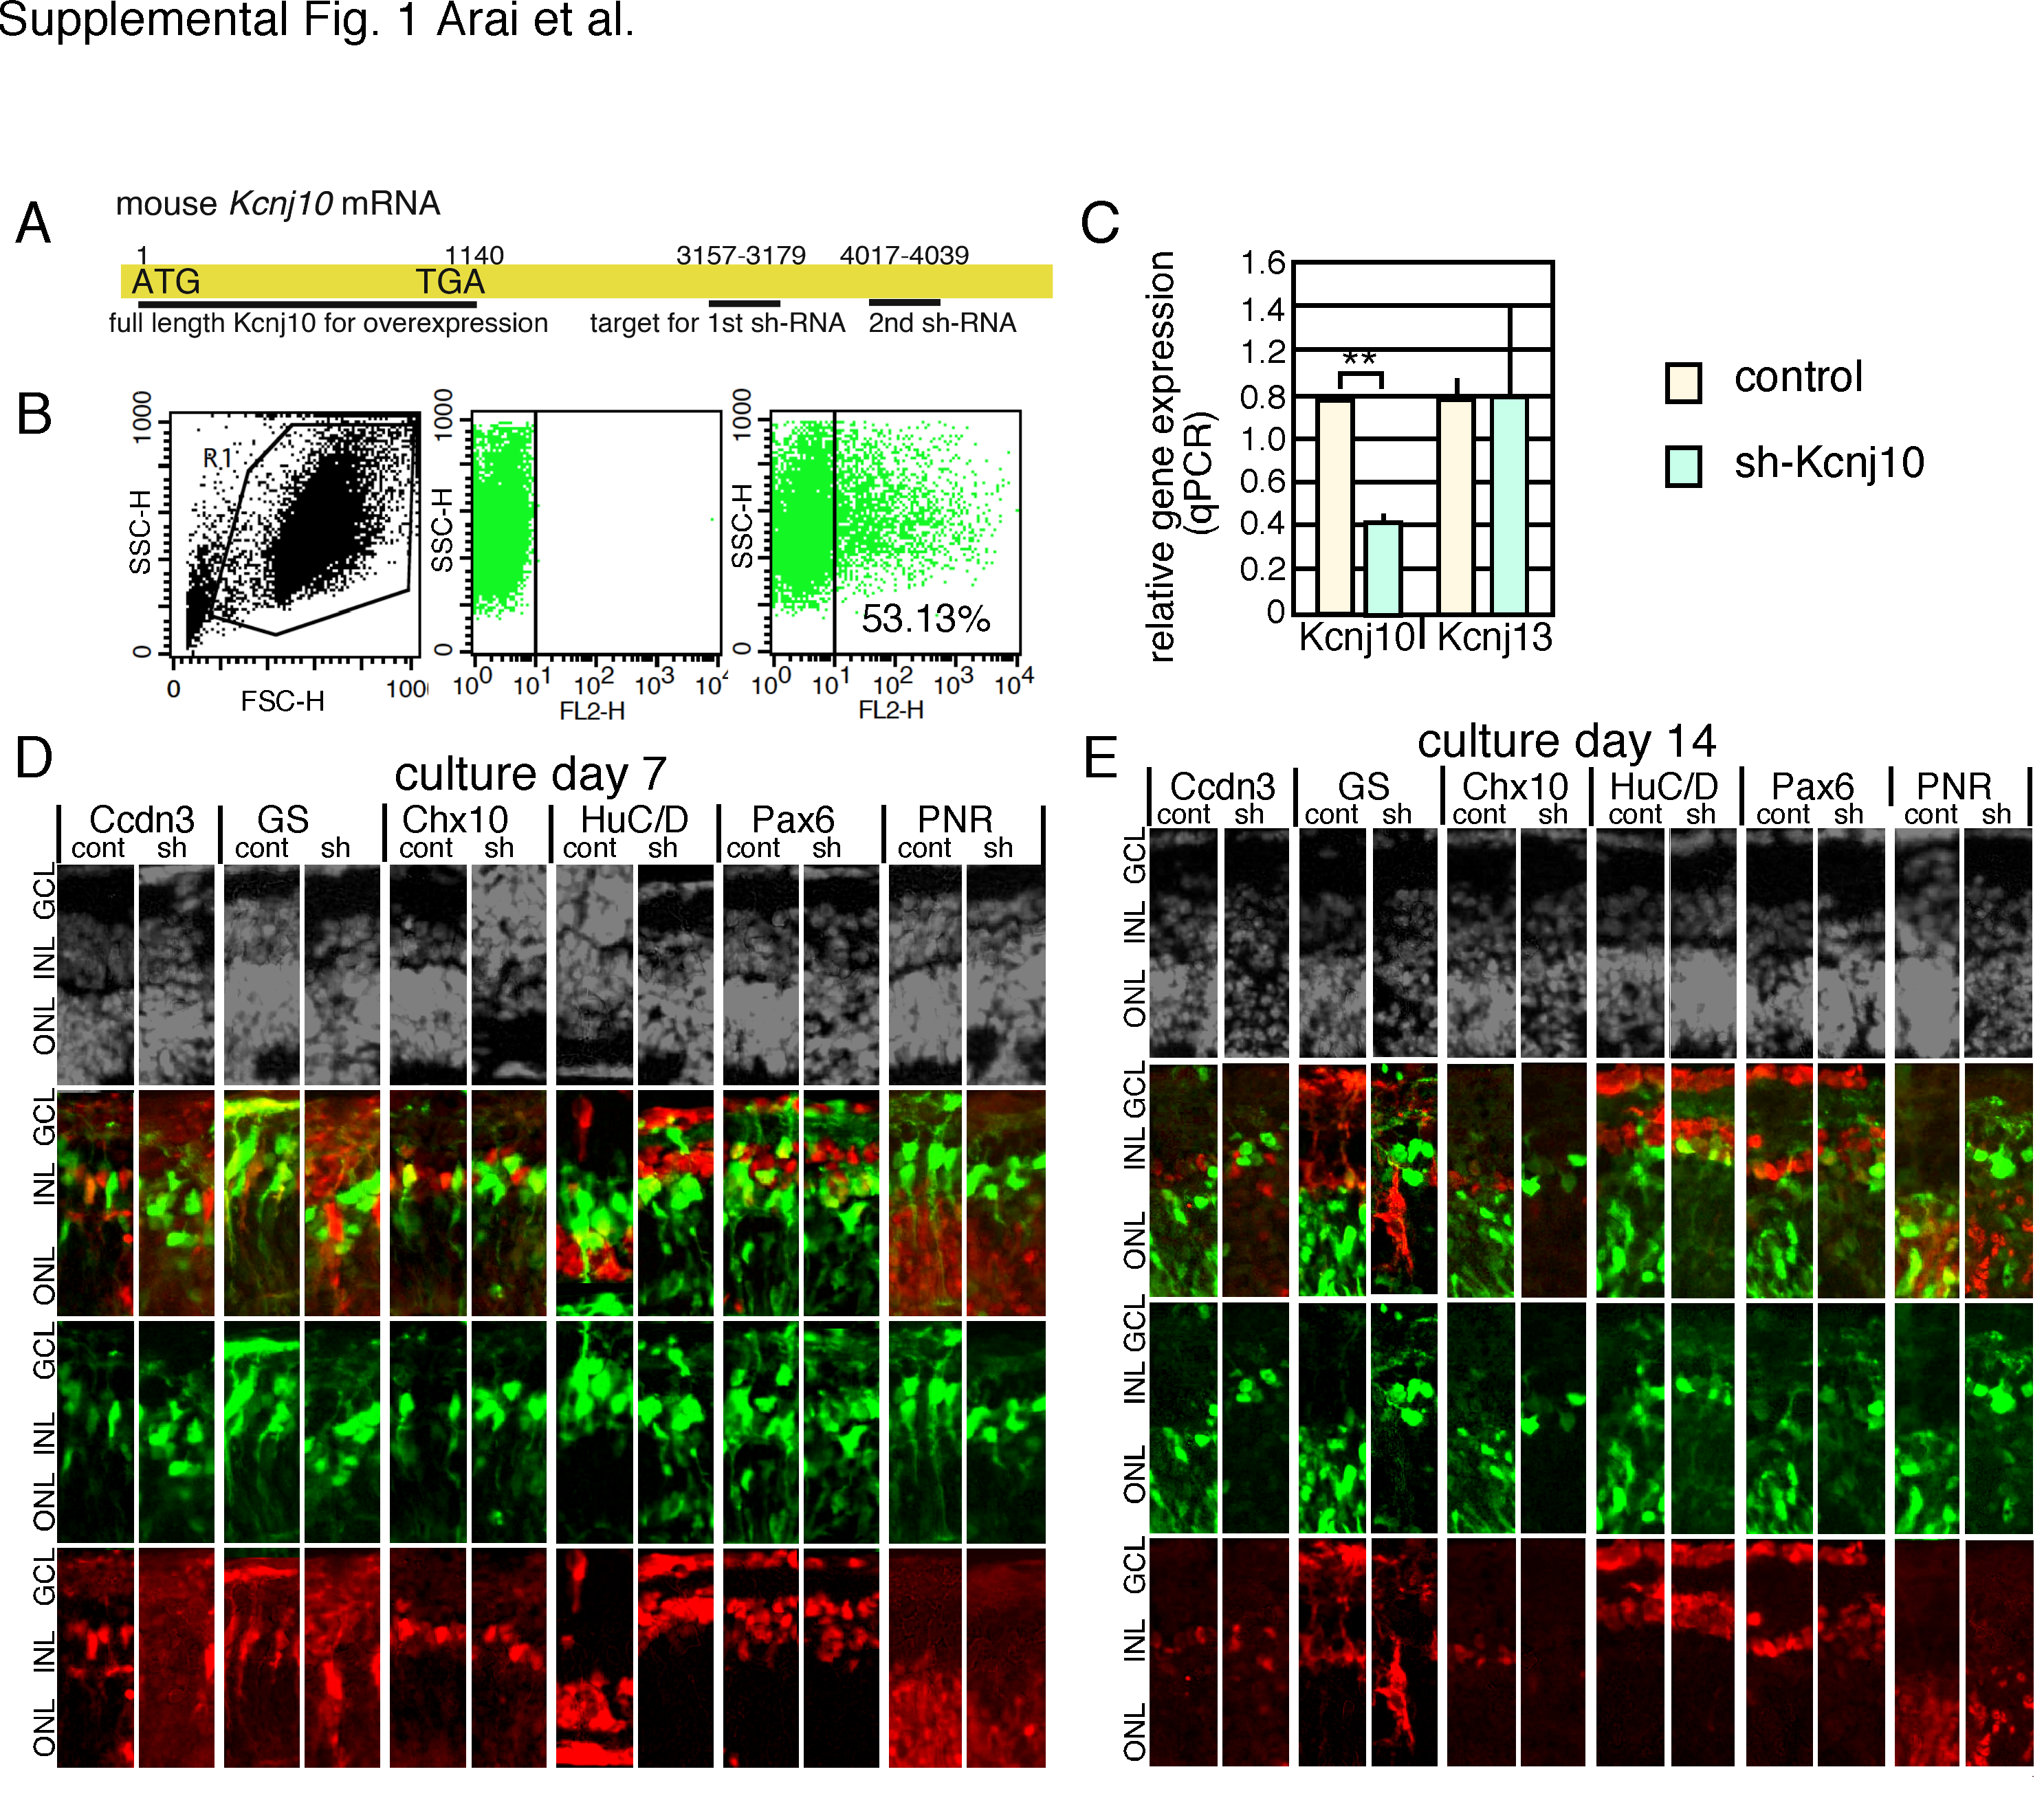
For overexpression, full lenght Kcnj10 covering the first ATG (1) to STOP codon (1140) was cloned under CAG promoter. Target sequcenses for sh-RNA located in 3’ UTR of Kcnj10 mRNA. B. Efficiency of electroporation using E19 retina was examined by Hes5-promoter-dsRed (addgene, 26868) after 48 hours of electroporation. Efficiency of ds-Red expression was examined by a cell sorter (FACSClibur, BD Bioscience). C. Effects of sh-Kcnj10 for mRNA expression levels of Kcnj10, Kcnj13, and Kcnj15. Control or sh-Kcnj10 plasmid was introduced in to retina at E18, and cultured for 48 hours. Then mRNA levels of Kcnj family members were examined by RT-qPCR. Level of Kcnj15 was too low to detect. Relative values to β-actin expression are shown. Values are average with standard deviation of 4 independent samples. ** <0.01 (Student’s t-test). D. E. Control-EGFP or sh-Kcnj10/EGFP expression plasmids were electroporeted into isolated retinas at E18, and retinas were cultures as explants for 7 (D) or 14 ) days. Immunostained pattern with DAPI staining are shown. cont, control; sh, sh-Kcnj10; ONL, outer nuclear layer; INL, inner nuclear layer; GCL, ganglion cell layer.

Supplemental Figure
Immunostaining pattern of in vitro, in vivo electroporated postnatal retina
Control or Kcnj10 expressing plasmids were electroporated into isolated retina at P1 (in vitro electroporation), or retina at live mice at P1 (in vivo electroporation). Then, after 12 days, retinas were harvested, or mice were sacrificed and retinas were isolated, and immunostaining of EGFP and retinal markers was done. All panels are placed as ganglion cell layer to the top.

